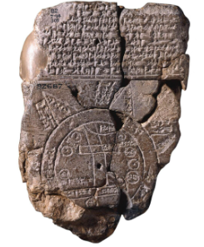The Imago Mundi is the oldest map ever recovered from antiquity. Written in Babylon 3000 years ago it is part of the vast collection at the British Museum. Complete with well known Mesopotamian geography, the map positions Babylon at the center of the world. The text on the tablet gives directions as well as distances from well known locations to a massive ship located in the mountains of Ararat. Alexander the Great is said to have visited this location after conquering the region. Similarly in Mesopotamian culture, the Epic of Gilgamesh is the oldest book ever recovered from antiquity. It is a story about a giant, a flood, an old man, a huge ship and animals. Irving Finkel, curator of the British Museum, teaches that the Bible stole the fable of the flood from the Epic of Gilgamesh. If so, then why is there a map to a place that still exists?

