The
GIANT
Problem

Written by
Byron Holtsclaw

Edited by Susan Chambers

FORWARD
This book about giants by Byron Holtsclaw is not traditional. Byron, of course, knows this and explains in advance that his goal is merely to be an expository teacher of the Bible. While sometimes quoting secular historians and scholars, his stated desire is to focus our attention on what the Bible says about giants. To this end he reproduces large sections of the Bible in his book. He illustrates the powerful influence of tradition by pointing out that for over 204 years the citizens of Indiana have misspelled the word “Daveiss” as in “Daviess County”. Not only is there no desire to correct this error, to the contrary the incorrect spelling has been adopted in other states such as Kentucky, Illinois, Missouri, and Minnesota. Unfortunately, many religious people also prefer tradition over truth.
Jeremiah reminds us that it is better to drink from a fountain than from a cistern (Jeremiah 3:13). Water directly from the fountain is pure, while mud is invariably at the bottom of a cistern. For this reason Paul insisted that the Gospel he preached came directly from Christ and not from men (Galatians 1:1). He further challenges everyone to follow him as he follows Christ (1 Corinthians 11:1). That is, neither Christ nor Paul received their message from men and neither should we. Paul was pleased when the noble Bereans refused to believe him and eagerly searched the Scriptures daily to see if what he said was true (Acts 17:11). I am convinced that Byron Holtsclaw will also be pleased if you also search the Scriptures to see if what he says is true. Since the Scriptures are alive and active, they are the primary vehicle God uses to shape and mold our thinking.
The reality of giants is a fact of history. Byron presents ample evidence of this. It is also clear from the Bible that the “sons of God” were somehow associated with giants. The “possibility” that these “sons of God” were supernatural beings having children with the “daughters of men” adds a new dimension to our understanding. If true, these hybrids would pose a special threat to the Messianic lineage. This could help explain repeated commands from God to exterminate entire groups of people. While you may question angelic men having children with human women, there should be no question that something similar to this brought Jesus into the world.
Regardless of your view on the origin of giants, it should be clear to everyone that we are engaged in spiritual warfare. Our ultimate struggle is not against flesh and blood, but against the powers of this dark world and against spiritual forces of evil in the heavenly realms (Ephesians 6:12). In this regard Byron’s research and writing is certainly a step in the right direction. We need to be constantly reminded of Satan’s diabolical influence in the world. What Job went through was not an accident. What we are going through is not an accident either. There is a spiritual component to every temptation we face. Carnal weapons, of course, are of no value against a spiritual opponent. That’s why the weapons we fight with are not the weapons of this world (2 Corinthians 10:3-6). Byron emphasizes the comforting fact that God was constantly involved in shaping history and is still a very present help in time of trouble (Psalms 46:1).
My favorite chapter is TIMING IS EVERYTHING. Regardless of divergent views on giants and other areas of controversy, the Christian world stands firm in the belief that our Sovereign God is in complete control. At just the right time God will send Jesus back to earth in flaming fire taking vengeance on them that know not God and obey not the Gospel (2 Thessalonians 1:7,8).
I consider Byron Holtsclaw a personal friend, and faithful brother in the Lord. I thank you in advance for taking time to read his book about giants.

Boyce Mouton,
Teacher & Writer
Carthage, Missouri

Table of Contents

Introduction page 10

Chapters:
- David’s Giants page 13

- Why David was Anointed as King page 21

- What was Reported to Moses page 30

- Og, King of Bashan page 36

- Gilgal Rephaim page 43

- The Walls Came Tumbling Down 47

- Abraham’s War page 56

- Noah Starts Over page 61

- Israel’s Destruction page 68

- Timing is Everything page 72

- Days of Noah page 77

- Native American Tales page 80

- Abraham Lincoln’s Address page 83

- Flavius Josephus page 91

- Baalbek page 94

- Nimrod page 98

- Maximinus Thrax page 105

- Walking with the Dinosaurs page 107

- Around the World page 110

- Megaliths page 119

- DNA Evidence page 123

- Make Believe page 126

- Logic page 128

Bibliography page 130

Index page 135

Introduction

While I have been a Christian thirty three years and a Bible teacher twenty eight years, often when I read the scripture I will find things that I do not understand. One of the things I did not understand motivated my research on this topic and thus has deepened my understanding in this area. The Bible has been written in Hebrew and Greek and then translated to Latin, English and many other modern languages. The study of what words mean and the path of the translation and the context of the use of these vocabularies is essential to our study of the scripture. Thank you for allowing me the privilege of sharing the result of my study. It is not my intent to spoon feed you my theology. It is my goal to show you how you can study to draw your own conclusions. May God richly bless your efforts to seek His truth and gain understanding.
While like many Bible students, I have opinions about what God has revealed to us in scripture. I am an expository teacher of God’s word. I simply desire to show the reader what God said in his word. “Where the Bible speaks, I speak. Where the Bible is silent, I am silent.” Also included in my work is the research of archeologists, anthropologists, biologists, geologists, physicians and historians who substantiate and support the scripture with the findings of their research.
Colonel Joseph Hamilton Daveiss commanded the Dragoons of the Indiana Militia at the Battle of Tippecanoe during the War of 1812. He died while volunteering to serve Governor William Henry Harrison’s call for troops to march against Shawnee warrior Tecumseh’s men at Prophetstown. Daveiss sacrificed his life in the Militia’s victory in the battle near Lafayette, Indiana and the United States ultimately was victorious over the British and Native American Confederacy in the War of 1812. Joseph Daveiss had married Nancy Marshall, the sister of Supreme Court Chief Justice John Marshall. Daveiss also served as the United States Attorney for the Commonwealth of Kentucky. He famously charged Aaron Burr with treason against the United States of America at the request of President Thomas Jefferson. The charges were dropped thanks to the maneuvering of Burr’s attorney, Henry Clay.
I serve Christ’s disciples in Washington, Indiana which is the county seat of the county named for Daveiss’ sacrifice as Indiana became a state in 1816 shortly after American victories secured the Midwest for settlement. Unfortunately, Daviess County is spelled incorrectly. We have spelled it incorrectly for over 210 years. People would become angry if you changed it now, “it’s always been that way.” It is also spelled wrong in counties named for Daveiss in Kentucky, Illinois, Missouri and Minnesota.
Daveiss is one example of how we’ve taught incorrect information and have passed down the incorrect information generation after generation. Good and faithful Christians have unknowingly and inadvertently taught or failed to teach the Bible generation after generation. “I’ve never heard that before!” is a common declaration I hear from mature church members after I teach a Bible lesson. My prayer is that the readers of this book will keep an open mind and study what I present diligently. It is possible that the discipline of History has even omitted a few minor things from the official record in order to fall in line at the request of authoritative figures and theories that assume too much.

Chapter 1
David’s Giants

Let us begin with the most familiar story and work toward things less familiar. Most of us are familiar with the David and Goliath battlefield story.
Goliath of Gath, 1015 A.D.
I Samuel 17:1-58

Now the Philistines gathered their forces for war and assembled at Socoh in Judah. They pitched camp at Ephes Dammim, between Socoh and Azekah. Saul and the Israelites assembled and camped in the Valley of Elah and drew up their battle line to meet the Philistines. The Philistines occupied one hill and the Israelites another, with the valley between them.
A champion named Goliath, who was from Gath, came out of the Philistine camp. He was over 9 feet tall. He had a bronze helmet on his head and wore a coat of scale armor of bronze weighing five thousand shekels (about 125 pounds); on his legs he wore bronze greaves, and a bronze javelin was slung on his back. His spear shaft was like a weaver’s rod, and its iron point weighed six hundred shekels (about 15 pounds). His shield bearer went ahead of him.
Goliath stood and shouted to the ranks of Israel, ‘Why do you come out and line up for battle? Am I not a Philistine, and are you not the servants of Saul? Choose a man and have him come down to me. If he is able to fight and kill me, we will become your subjects; but if I overcome him and kill him, you will become our subjects and serve us.’ Then the Philistine said, ‘This is the day I defy the ranks of Israel! Give me a man and let us fight each other.’ On hearing the Philistine’s words, Saul and all the Israelites were dismayed and terrified.
Now David was the son of an Ephrathite named Jesse, who was from Bethlehem in Judah. Jesse had eight sons, and in Saul’s time he was old and well advanced in years. Jesse’s three oldest sons had followed Saul to the war: the firstborn was Eliab; the second, Abinadab; and the third, Shammah. David was the youngest. The three oldest followed Saul, but David went back and forth from Saul to tend his father’s sheep at Bethlehem.
For forty days the Philistine came forward every morning and evening and took his stand.
Now Jesse said to his son David, ‘Take this ephah (about 3/5 bushel) of roasted grain and these ten loaves of bread for your brothers and hurry to their camp. Take along these ten cheeses to the commander of their unit. See how your brothers are and bring back some assurance from them. They are with Saul and all the men of Israel in the Valley of Elah, fighting against the Philistines.’
Early in the morning David left the flock with a shepherd, loaded up and set out, as Jesse had directed. He reached the camp as the army was going out to its battle positions, shouting the war cry. Israel and the Philistines were drawing up their lines facing each other. David left his things with the keeper of supplies, ran to the battle lines and greeted his brothers. As he was talking with them, Goliath, the Philistine champion from Gath, stepped out from his lines and shouted his usual defiance, and David heard it. When the Israelites saw the man, they all ran from him in great fear.
Now the Israelites had been saying, ‘Do you see how this man keeps coming out? He comes out to defy Israel. The king will give great wealth to the man who kills him. He will also give him his daughter in marriage and will exempt his father’s family from taxes in Israel.’
David asked the men standing near him, ‘What will be done for the man who kills this Philistine and removes this disgrace from Israel? Who is this uncircumcised Philistine that he should defy the armies of the living God?’
They repeated to him what they had been saying and told him, ‘This is what will be done for the man who kills him.’
When Eliab, David’s oldest brother, heard him speaking with the men, he burned with anger at him and asked, ‘Why have you come down here? And with whom did you leave those few sheep in the desert? I know how conceited you are and how wicked your heart is; you came down only to watch the battle.’
‘Now what have I done?’ said David. ‘Can’t I even speak?’ He then turned away to someone else and brought up the same matter, and the men answered him as before. What David said was overheard and reported to Saul, and Saul sent for him.
David said to Saul, ‘Let no one lose heart on account of this Philistine; your servant will go and fight him.’
Saul replied, ‘You are not able to go out against this Philistine and fight him; you are only a boy, and he has been a fighting man from his youth.’
But David said to Saul, ‘Your servant has been keeping his father’s sheep. When a lion or a bear came and carried off a sheep from the flock, I went after it, struck it and rescued the sheep from its mouth. When it turned on me, I seized it by its hair, struck it and killed it. Your servant has killed both the lion and the bear; this uncircumcised Philistine will be like one of them, because he has defied the armies of the living God. The LORD who delivered me from the paw of the lion and the paw of the bear will deliver me from the hand of the Philistine.’
Saul said to David, ‘Go, and the LORD be with you.’
Then Saul dressed David in his own tunic. He put a coat of armor on him and a bronze helmet on his head. David fastened on his sword over the tunic and tried walking around, because he was not used to them.
‘I cannot go in these,’ he said to Saul, ‘because I am not used to them.’ So he took them off. Then he took his staff in his hand, chose five smooth stones from the stream, put them in the pouch of his shepherd’s bag and, with his sling in his hand, approached the Philistine.
Meanwhile, the Philistine, with his shield bearer in front of him, kept coming closer to David. He looked David over and saw that he was only a boy, ruddy and handsome, and he despised him. He said to David, ‘Am I a dog, that you come at me with sticks?’ And the Philistine cursed David by his gods. ‘Come here,’ he said, ‘and I’ll give your flesh to the birds of the air and the beasts of the field!’
David said to the Philistine, ‘You come at me with a sword and spear and javelin, but I come against you in the name of the LORD Almighty, the God of the armies of Israel, whom you have defied. This day the LORD will hand you over to me, and I’ll strike you down and cut off your head. Today I will give the carcasses of the Philistine army to the birds of the air and the beasts of the earth, and the whole world will know that there is a God in Israel. All those gathered here will know that it is not by sword or spear that the LORD saves; for the battle is the LORD’s and he will give all of you into our hands.’
As the Philistine moved closer to attack him, David ran quickly toward the battle line to meet him. Reaching into his bag and taking out a stone, he slung it and struck the Philistine on the forehead. The stone sank into his forehead, and he fell facedown on the ground.
So David triumphed over the Philistine with a sling and a stone; without a sword in his hand he struck down the Philistine and killed him.
David ran and stood over him. He took hold of the Philistine’s sword and drew it from the scabbard. After he killed him, he cut off his head with the sword.
When the Philistines saw that their hero was dead, they turned and ran. Then the men of Israel and Judah surged forward with a shout and pursued the Philistines to the entrance of Gath and to the gates of Ekron. Their dead were strewn along the Shaaraim road to Gath and Ekron. When the Israelites returned from chasing the Philistines, they plundered the camp. David took the Philistine’s head and brought it to Jerusalem, and he put the Philistine’s weapons in his own tent.
As Saul watched David going out to meet the Philistine, he said to Abner, commander of the army, ‘Abner, whose son is that young man?’
Abner replied, ‘As surely as you live, O king, I don’t know.’
The king said, ‘Find out whose son this young man is.’
As soon as David returned from killing the Philistine, Abner took him and brought him before Saul, with David still holding the Philistine’s head.
‘Whose son are you, young man? Saul asked him. David said, ‘I am the son of your servant Jesse of Bethlehem.’

My position on the Old and New Testaments of the Bible is that the events LITERALLY happened. The stories are not allegory or fables that we are intended to glean morals from. King David is a historical person who ruled Israel and Judah from 1010-970 B.C.E. His home town of Bethlehem is where Jesus of Nazareth was born about a thousand years later. David was a talented musician who wrote many of the 150 Psalms.
Scholars debate if Goliath was really over 9 feet tall. How do we know that he wore 125 pound armor? Or that his javelin point weighed 15 pounds? David is said to have kept these items as trophies after defeating Goliath (I Samuel 17:54).
The metaphor of “David and Goliath” is world renown meaning that someone has a clear advantage as well as someone has a clear disadvantage. I have heard it argued that Goliath was a mere genetic freak that could not fight well. If true, why were the armies of Israel afraid of him and why was King Saul unwilling to let David fight him? Goliath was a seasoned champion of the battlefield who was used to dominating his opponents. This explains his boldness to daily blaspheme the God of Israel in the presence of Saul’s army. In fact, by the day of this battle, the armies of Israel had heard much about the likes of Goliath. In chapter 2 we will deal with the first generation of Israel’s attitude toward the situation in the land of Canaan.

Then he took his staff in his hand, chose five smooth stones from the stream, put them in the pouch of his shepherd’s bag and, with his sling in his hand, approached the Philistine. I Samuel 17:40
Four More Stones in the Shepherd’s Bag = Four More Giants to Fight

II Samuel 21:15-22, Around 1000 A.D.
“Once again there was a battle between the Philistines and Israel. David went down with his men to fight against the Philistines, and he became exhausted. And Ishbi-Benob, one of the descendants of Rapha, whose bronze spearhead weighed three hundred shekels (about 7 ½ pounds) and who was armed with a new sword, said he would kill David. But Abishai son of Zeruiah came to David’s rescue; he struck the Philistine down and killed him. Then David’s men swore to him, saying, ‘Never again will you go out with us to battle, so that the lamp of Israel will not be extinguished.’
In the course of time, there was another battle with the Philistines, at Gob. At that time Sibbecai the Hushathite killed Saph, one of the descendants of Rapha.
In another battle with the Philistines at Gob, Elhanan son of Jair the Bethlehemite killed Lahmi the brother of Goliath, who had a spear with a shaft like a weaver’s rod.
In still another battle, which took place at Gath, there was a huge man with six fingers on each hand and six toes on each foot – twenty-four in all. He also was descended from Rapha. When he taunted Israel, Jonathan son of Shimeah, David’s brother, killed him.
These four were descendants of Rapha in Gath, and they fell at the hands of David and his men.

Now, compare the text you just read in II Samuel 21 to this text found in I Chronicles 20:4-8.

In the course of time, war broke out with the Philistines, at Gezer. At that time Sibbecai the Hushathite killed Sippai, one of the descendants of the Rephaites, and the Philistines were subjugated.
In another battle with the Philistines, Elhanan son of Jair killed Lahmi the brother of Goliath the Gittite, who had a spear with a shaft like a weaver’s rod.
In still another battle, which took place at Gath, there was a huge man with six fingers on each hand and six toes on each foot – twenty-four in all. He also was descended from Rapha. When he taunted Israel, Jonathan son of Shimea, David’s brother, killed him.
These were the descendants of Rapha in Gath, and they fell at the hands of David and his men.

Rephaim are listed twenty times in the Old Testament. (Keep reading this book and you will see with what stories Rephaim are associated with.) Goliath of Gath and the four other giants listed dually in II Samuel and I Chronicles are Rephaim; meaning the descendants of Rapha as the text indicates.
Isaiah the prophet uses the Hebrew word Rephaim when proclaiming those who once ruled but now are in Sheol, a Hebrew word for the place of the dead. Pagan religions and the occult have long practiced the idea that these spirits could be summoned from the dead. The Hebrews taught that God gave the Rephaim the specific realm of Sheol to await the final judgement. Moses warned the Israelites to never practice such a ritual as the people of Canaan did in summoning them from the underworld.
Most uses of Rephaim are referencing the fact of a bloodline of giants that can be traced in record all the way back to Genesis 6. This book is an attempt to generation by generation show the record of this race of people who are world renown. Throughout this book we will list the characteristics of these mighty men. The unnamed giant that David’s men killed was described as having 6 digits on each appendage. This characteristic is a malformation known in medical journals as polydactylism. This is the only Biblical reference to this abnormality, but the Old Testament twice describes the same giant. In chapter 10 of this book you will read more about 6 fingered hands.
If you are a healthy person you may attempt to throw a 15 pound object like the point of Goliath’s javelin or you may walk around with 125 pounds on your back to feel the weight of his armor.
David had to exterminate these mighty men because his Hebrew ancestors disobeyed God’s command to kill every man, woman and child of this ancient race of giants. As you read these chapters it will become evident just what exactly is the Giant Problem.

Chapter 2
Why David was Anointed as King

I Samuel 28:17&18
“The LORD has torn the kingdom out of your hands and given it to one of your neighbors – to David. Because you did not obey the LORD or carry out his fierce wrath against the Amalekites, the LORD has done this to you today.”

The Gospel of Matthew in the New Testament starts with the Genealogy of Jesus of Nazareth. 14 generations from Abraham to David, 14 from David to the exile to Babylon, and 14 from the exile to the Messiah. It is strange that Saul was anointed the first king of Israel by Samuel the prophet only to have Samuel later anoint a man from a different family king. What happened that God chose another man to lead his people and begat the coming Son of God?

Why God Rejected Saul as King
I Samuel 15:1-34
Samuel said to Saul, “I am the one the LORD sent to anoint you king over his people Israel; so listen now to the message from the LORD. This is what the LORD Almighty says: ‘I will punish the Amalekites for what they did to Israel when they waylaid them as they came up from Egypt. Now go, attack the Amalekites and totally destroy everything that belongs to them. Do not spare them; put to death men and women, children and infants, cattle and sheep, camels and donkeys.’
So Saul summoned the men and mustered them at Telaim – two hundred thousand foot soldiers and ten thousand men from Judah. Saul went to the city of Amalek and set an ambush in the ravine. Then he said to the Kenites, ‘Go away, leave the Amalekites so that I do not destroy you along with them; for you showed kindness to all the Israelites when they came up out of Egypt.’ So the Kenites moved away from the Amalekites.
Then Saul attacked the Amalekites all the way from Havilah to Shur, to the east of Egypt. He took Agag king of the Amalekites alive, and all his people he totally destroyed with the sword. But Saul and the army spared Agag and the best of the sheep and cattle, the fat calves and lambs – everything that was good. These they were unwilling to destroy completely, but everything that was despised and weak they totally destroyed.
Then the word of the LORD came to Samuel: ‘I am grieved that I have made Saul king, because he has turned away from me and has not carried out my instructions.’ Samuel was troubled, and he cried out to the LORD all that night.
Early in the morning Samuel got up and went to meet Saul, but he was told, ‘Saul has gone to Carmel. There he has set up a monument in his own honor and has turned and gone down to Gilgal.’
When Samuel reached him, Saul said, ‘The LORD bless you! I have carried out the LORD’s instructions.’
But Samuel said, ‘What then is this bleating of sheep in my ears? What is this lowing of cattle that I hear?’
Saul answered, ‘The soldiers brought them from the Amalekites; they spared the best of the sheep and cattle to sacrifice to the LORD your God, but we totally destroyed the rest.’
‘Stop!’ Samuel said to Saul. ‘Let me tell you what the LORD said to me last night.’
‘Tell me,’ Saul replied.
Samuel said, ‘Although you were once small in your own eyes, did you not become the head of the tribes of Israel? The LORD anointed you king over Israel. And he sent you on a mission saying, ‘Go and completely destroy those wicked people, the Amalekites; make war on them until you have wiped them out.’ Why did you not obey the LORD? Why did you pounce on the plunder and do evil in the eyes of the LORD?’
‘But I did obey the LORD,’ Saul said. ‘I went on the mission the LORD assigned me. I completely destroyed the Amalekites and brought back Agag their king. The soldiers took sheep and cattle from the plunder, the best of what was devoted to God, in order to sacrifice them to the LORD your God at Gilgal.’
But Samuel replied:
‘Does the LORD delight in burnt offerings and sacrifices
as much as in obeying the voice of the LORD?
To obey is better than sacrifice,
and to heed is better than the fat of rams.
For rebellion is like the sin of divination,
and arrogance like the evil of idolatry.
Because you have rejected the word of the LORD,
he has rejected you as king.’

Then Saul said to Samuel, ‘I have sinned. I violated the LORD’s command and your instructions. I was afraid of the people and so I gave in to them. Now I beg you, forgive my sin and come back with me, so that I may worship the LORD.’
But Samuel said to him, ‘I will not go back with you. You have rejected the word of the LORD, and the LORD has rejected you as king over Israel!’
As Samuel turned to leave, Saul caught hold of the hem of his robe, and it tore. Samuel said to him, ‘The LORD has torn the kingdom of Israel from you today, and has given it to one of your neighbors – to one better than you. He who is the Glory of Israel does not lie or change his mind; for he is not a man, that he should change his mind.’
Saul replied, ‘I have sinned. But please honor me before the elders of my people and before Israel; come back with me, so that I may worship the LORD your God.’ So Samuel went back with Saul, and Saul worshiped the LORD.’
The Samuel said, ‘Bring me Agag king of the Amalekites.’
Agag came to him confidently, thinking, ‘Surely the bitterness of death is past.’
But Samuel said,
‘As your sword has made women childless,
so will your mother be childless among women.’
And Samuel put Agag to death before the LORD at Gilgal.
Then Samuel left for Ramah, but Saul went up to his home in Gibeah of Saul. Until the day Samuel died, he did not go see Saul again, though Samuel mourned for him. And the LORD was grieved that he had made Saul king over Israel.

God Chooses David as King
I Samuel 16:1-13

The LORD said to Samuel, ‘How long will you mourn for Saul, since I have rejected him as king over Israel? Fill your horn with oil and be on your way; I am sending you to Jesse of Bethlehem. I have chosen one of his sons to be king.’
But Samuel said, ‘How can I go? Saul will hear about it and kill me.’
The LORD said, ‘Take a heifer with you and say, “I have come to sacrifice to the LORD.” Invite Jesse to the sacrifice, and I will show you what to do. You are to anoint for me the one I indicate.’
Samuel did what the LORD said. When he arrived at Bethlehem, the elders of the town trembled when they met him. They asked, ‘Do you come in peace?’
Samuel replied, ‘Yes, in peace; I have come to sacrifice to the LORD. Consecrate yourselves and come to the sacrifice with me.’ Then he consecrated Jesse and his sons and invited them to the sacrifice.
When they arrived, Samuel saw Eliab and thought, ‘Surely the LORD’s anointed stands here before the LORD.’
But the LORD said to Samuel, ‘Do not consider his appearance or his height, for I have rejected him. The LORD does not look at the things man looks at. Man looks at the outward appearance, but the LORD looks at the heart.’
Then Jesse called Abinadab and had him pass in front of Samuel. But Samuel said, ‘The LORD has not chosen this one either.’ Jesse then had Shammah pass by, but Samuel said, ‘Nor has the LORD chosen this one.’ Jesse had seven of his sons pass before Samuel, but Samuel said to him, ‘The LORD has not chosen these.’ So he asked Jesse, ‘Are these all of the sons you have?’
‘There is still the youngest,’ Jesse answered, ‘but he is tending the sheep.’
Samuel said, ‘Send for him; we will not sit down until he arrives.’
So he sent and had him brought in. He was ruddy, with a fine appearance and handsome features.
Then the LORD said, ‘Rise and anoint him; he is the one.’
So Samuel took the horn of oil and appointed him in the presence of his brothers, and from that day on the Spirit of the LORD came upon David in power. Samuel then went to Ramah.

God commanded Saul to kill the Amalekites; all of them, men, women, children and all of their animals. Saul disobeyed and God took away his crown. Why the harsh punishment from God?
The prophet Samuel kills Agag, king of the Amalekites, himself executing God’s judgement on the clan of Rephaim. God’s plan to kill all of the Rephaim living in the land of Canaan was not a matter of compromise or ideas to be debated by the Israelites.
Many today make an argument that a “Loving God” would not order the execution of old men, women, children and innocent animals. To ask why God wanted this clan wiped off of the face of the earth is at the essence this book’s purpose. Yes, God was deliberately wiping out those who were not in his plan for redemption and eternal blessing. Saul’s unwillingness to carry out this plan of God’s was his downfall. A prerequisite of the new king was his obedience to God’s plan to exterminate this race of giants.
God chose ‘a man after his own heart’ to be king. David was anointed by Samuel while he was still a boy. God’s spirit was upon him and David exhibited the power of God dwelling in the shepherd boy when he slayed Goliath with a single stone. Why did he then select 5 stones from the stream to place in his bag? He would later slay the remaining 4 giants living in Canaan (see chapter 1 of The Giant Problem). This mission was essential to the legacy of King David.
It is no coincidence that David’s first military operation as an adult was to clean up what Saul had left undone. God’s plan was to wipe out the Amalekites and God handed them to David’s army for a subsequent total victory.

David destroys the Amalekites, 1010 A.D
I Samuel 30:1-20
David and his men reached Ziklag on the third day. Now the Amalekites had raided the Negev and Ziklag. They had attacked Ziklag and burned it, and had taken captive the women and all who were in it, both young and old. They killed none of them, but carried them off as they went on their way.
When David and his men came to Ziklag, they found it destroyed by fire and their wives and sons and daughters taken captive. So David and his men wept aloud until they had no strength left to weep. David’s two wives had been captured – Ahinoam of Jezreel and Abigail, the widow of Nabal of Carmel. David was greatly distressed because the men were talking of stoning him; each one was bitter in spirit because of his sons and daughters. But David found strength in the LORD his God.
Then David said to Abiathar the priest, the son of Ahimelech, ‘Bring me the ephod.’ Abiathar brought it to him, and David inquired of the LORD, ‘Shall I pursue this raiding party? Will I overtake them?’
‘Pursue them,’ he answered. ‘You will certainly overtake them and succeed in the rescue.’
David and the six hundred men with him came to Besor Ravine, where some stayed behind, for two hundred men were too exhausted to cross the ravine. But David and four hundred men continued the pursuit.
They found an Egyptian in a field and brought him to David. They gave him water to drink and food to eat – part of a cake of pressed figs and two cakes of pressed raisins. He ate and was revived, for he had not eaten any food or drunk any water for three days and three nights.
David asked him, ‘To whom do you belong, and where do you come from?’
He said, ‘I am an Egyptian, the slave of an Amalekite. My master abandoned me when I became ill three days ago. We raided the Negev of Caleb. And we burned Ziklag.’
David asked him, ‘Can you lead me down to this raiding party?’
He answered, ‘Swear to me before God that you will not kill me or hand me over to my master, and I will take you down to them.’
He lead David down, and there they were, scattered over the countryside, eating, drinking and reveling because of the great amount of plunder they had taken from the land of the Philistines and from Judah. David fought them from dusk until the evening of the next day, and none of them got away. David recovered everything the Amalekites had taken, including his two wives. Nothing was missing; young or old, boy or girl, plunder or anything else they had taken. David brought everything back. He took all the flocks and the herds, and his men drove them ahead of the other livestock, saying, ‘This is David’s plunder.’

Do not be appalled, as many are that God, ordered genocide a people group. First of all, we simply don’t have all the information. Please bare with me in my humble attempt to clearly translate the information we do have from the scripture. Job stated, “The LORD giveth and the LORD taketh away, blessed be the name of the LORD.” God is just in creating and destroying life. God’s plan is holy. Through David’s obedience, God destroyed the evil Rephaim.
Just as David defeated Goliath with a single stone, he also destroyed a race of giants that Saul refused to wipe out. The spirit of God was upon the young man and the power of God flowed through is veins. The full blessing of God was now resting upon the throne of David and the tribe of Judah. 28 generations later, God would send his one and only Son, born from David’s ancestry to redeem what was lost: mankind.

II Samuel 8:2
David also defeated the Moabites. He made them lie down on the ground and measured them off with a length of cord. Every two lengths of them were put to death, and the third length was allowed to live. So the Moabites became subject to David and brought tribute.

Moab was a nation to the southeast of the Dead Sea near the clans of giants living in the promised land. Like all nations who border each other, intermarriage is common. Understand that when David conquered Moab he had everyone measured. They were ordered to lie down for this. This method would be the only way to get an accurate measurement of someone much taller than you. It was predetermined what measurement constituted a giant. Those that fit that criteria were executed. Those who did not meet the criteria were given the gift of life in the kingdom of David. Wow, condemnation and judgement to one group, while simultaneously granting salvation and abundant life to the other group.

Chapter 3
What was Reported to Moses

Numbers is often overlooked when people study the Bible because many people see the censuses recording the population of Israel and assume this is boring reading. However, there are many fascinating details recorded about the encounters of the nation of Israel such as the exploration of the land of Canaan.
Chapter 13 of Numbers records that God told Moses to send a leader from each of the 12 tribes of Israel to explore Canaan.
Numbers 13:21-33
So they went up and explored the land from the Desert of Zin as far as Rehob, toward Lebo Hamath. They went up through the Negev and came to Hebron, where Ahiman, Sheshai and Talmai, the descendants of Anak, lived. (Hebron had been built seven years before Zoan in Egypt.) When they reached the Valley of Eshcol, they cut off a branch bearing a single cluster of grapes. Two of them carried it on a pole between them, along with some pomegranates and figs. That place was called the Valley of Eshcol because of the cluster of grapes the Israelites cut off there. At the end of forty days they returned from exploring the land.

Isaiah 26 and Psalm 78 mention Zoan, Egypt. It is the place where Moses performed the wonders in the presence of Pharaoh asking him to release Israel from his rule. The Greeks call this place Tanis. You may remember Tanis was the city that Indiana Jones was excavating in Raiders of the Lost Ark. In real life the city was lost for hundreds of years until a French archeologist began digging up Tanis during World War II. No, the Ark of the Covenant was not there! Moses tells us that the ancient city of Hebron in Canaan was 7 years older than the once capital city of Egypt; Zoan. Eye witness accounts suggest that it was well fortified, but more import, the spies tell Moses who lived there. Then there is the ridiculous fact of the grapes! I am not disputing the size of the grapes. If you have giant people living there, why couldn’t you have giant grapes growing there? The grapes were so incredibly large that 2 men carry the cluster on a pole and they name the very place where they found the grapes growing “Eshcol” (cluster in Hebrew): that is to say, valley of the cluster! Certainly, a memory not soon forgotten by the Israelites.

They came back to Moses and Aaron and the whole Israelite community at Kadesh in the Desert of Paran. There they reported to them and to the whole assembly and showed them the fruit of the land. They gave Moses this account: ‘We went into the land to which you sent us, and it does flow with milk and honey! Here is its fruit. But the people who live there are powerful, and the cities are fortified and very large. We even saw descendants of Anak there. The Amalekites live in the Negev; the Hittites, Jebusites and Amorites live in the hill country; and the Canaanites live near the sea and along the Jordan.’
The Caleb silenced the people before Moses and said, ‘We should go up and take possession of the land, for we can certainly do it.’
But the men who had gone up with him said, ‘We can’t attack those people; they are stronger than we are.’ And they spread among the Israelites a bad report about the land they had explored. They said, ‘The land we explored devours those living in it. All the people we saw there are of great size. We saw Nephilim there (the descendants of Anak come from the Nephilim). We seemed like grasshoppers in our own eyes, and we looked the same to them.’

Five clans of giants were listed in the report to Moses; Amalekites, Hittites, Jebusites, Amorites and Canaanites. When you read these clans listed in the Old Testament you must put them in the context of Anak, Rephaim and Nephilim; the Hebrew words for giants. That’s correct, there were many giants in many clans. The Israelites compared themselves to the people of Canaan as grasshoppers. The simile of grasshoppers may seem like an exaggeration but then you read the simile used in the Prophet Amos to describe the Amorites. Amos 2:9 reads, “Yet I destroyed the Amorites before them, whose height was like cedars”. The Bible mentions the “Cedars of Lebanon” 70 times. Solomon built the Temple of the Lord out of these renown conifers. This species of tree reaches 130 feet!

List of Raphaites
Deuteronomy 2:1-23
Emites, Anakites, Horites, Zamzummites are all called Rephaites by Moses (giants). The Old Testament has now given us a list of nine clans of giants. Five clans living in the land of Canaan during the time of Moses and 4 more clans living in the region before that time.

Detestable Practices
Deuteronomy 18:9-14
“When you enter the land the LORD your God is giving you, do not learn to imitate the detestable ways of the nations there. Let no one be found among you who sacrifices his son or daughter in the fire, who practices divination or sorcery, interprets omens, engages in witchcraft, or casts spells, or who is a medium or spiritist or who consults the dead. Anyone who does these things is detestable to the LORD, and because of these detestable practices the LORD your God will drive out those nations before you. You must be blameless before the LORD your God.
The nations you will dispossess listen to those who practice sorcery or divination. But as for you, the LORD your God has not permitted you to do so.”

The clans who inhabited the land of Canaan worshipped Baal and Molech. The bronze idols would be heated by fire and women would sacrifice their infants through the fire burning them alive. There are six things that God hates and seven that are detestable to him; one of which is the shedding of innocent blood. God loves innocent children and hates those who harm them. Jesus said that it would be better that a large millstone be tied to one’s neck and tossed in the sea than a man on the Day of Judgement who had harmed a child.
It is my contention that the human sacrifice and sorcery were directly linked to the tradition of the Rephaites. The Hebrew term Rephaite means “giants” and also those who have died. Those who lived in Canaan were known for calling up the dead and communicating with spirits of the underworld. King Saul of Israel used this capability against God’s command in asking the Witch of Endor to consult the dead prophet Samuel (I Samuel 28). Just as a reminder, the Witch of Endor was successful in communicating with Samuel, who was dead.
In Chapter 5 we will discuss an ancient temple of the Rephaim that exists still to this day. It is no coincidence that the temple is located exactly where the Bible says that these giants once ruled the region and practiced evil in the eyes of the LORD.
Twice evil leaders decreed that all male children be executed; Pharaoh and King Herod gave such an order. Both were attempts to thwart God’s plan for salvation. Even though Hebrew boys paid the price, Moses was taken out of the Nile River by the daughter of Pharaoh. Even though the young boys near Bethlehem were slaughtered, out of Egypt God called his son, Jesus. The will of God overcame the schemes of evil.

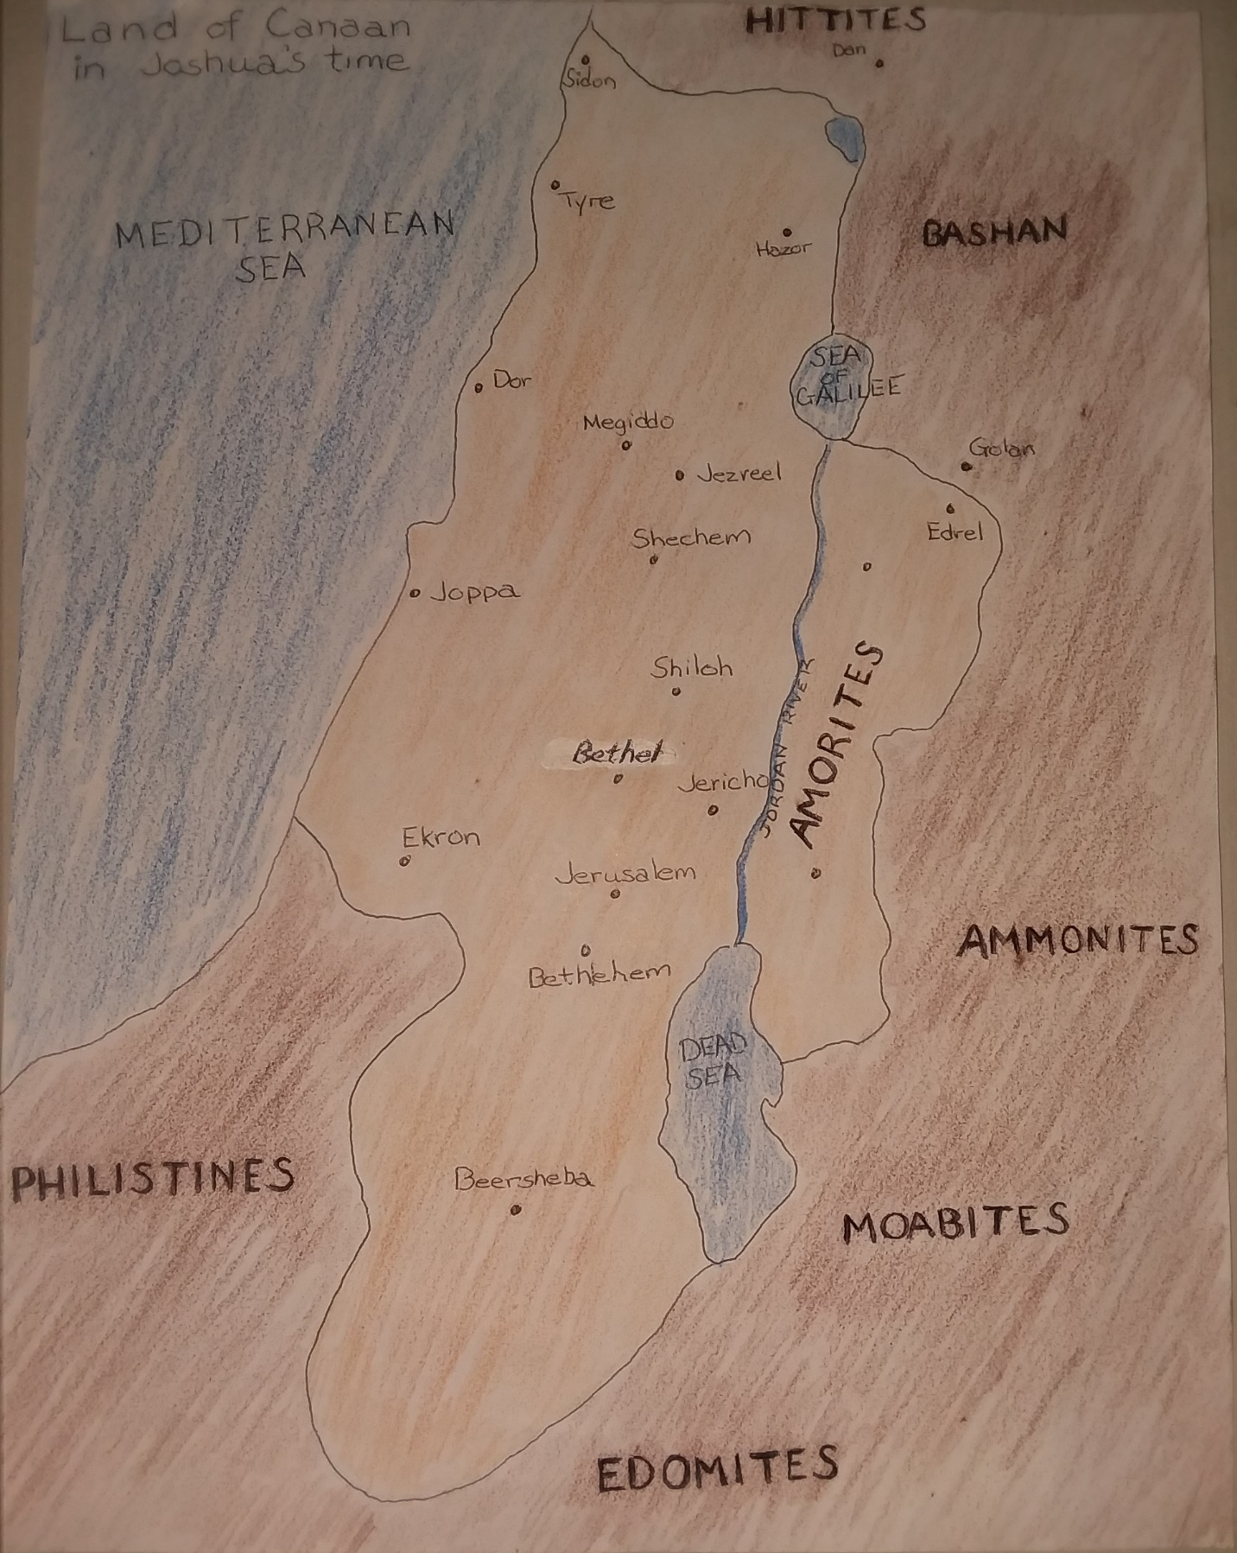

Chapter 4
Og, King of Bashan

Moses Defeats Sihon, Amorite King
Deuteronomy 2:24-37

“Set out now and cross the Amon Gorge. See, I have given into your hand Sihon the Amorite, king of Heshbon, and his country. Begin to take possession of it and engage him in battle. This very day I will begin to put the terror and the fear of you on all the nations under heaven. They will hear reports of you and will tremble and be in anguish because of you.”
From the desert of Kedemoth I sent messengers to Sihon king of Heshbon offering peace and saying, “Let us pass through your country. We will stay on the main road; we will not turn aside to the right or to the left. Sell us food to eat and water to drink for their price in silver. Only let us pass through on foot – as the descendants of Esau, who live in Seir, and the Moabites, who live in Ar, did for us – until we cross the Jordan into the land the LORD our God us giving us.” But Sihon king of Heshbon refused to let us pass through. For the LORD your God had made his spirit stubborn and his heart obstinate in order to give him into your hands, as he has now done.
The LORD said to me, “See, I have begun to deliver Sihon and his country over to you. Now begin to conquer and possess his land.”
When Sihon and all of his army came out to meet us in battle at Jahaz, the LORD our God delivered him over to us and we struck him down, together with his sons and his whole army. At that time we took all his towns and completely destroyed them – men, women, children. We left no survivors. But livestock and the plunder of the from the towns we had captured we carried off for ourselves. From Aroer on the rim of the Amon Gorge, and from the town in the gorge, even as far as Gilead, not one town was too strong for us. The LORD God gave us all of them. But in accordance with the command of the LORD our God, you did not encroach on any of the land of the Ammonites, neither the land along the course of the Jabbok nor that around the towns in the hills.

God used the army of Israel to wipe the Ammonite kingdoms off of the face of the earth. Many academic argue that there is no physical evidence that these people ever existed. Exactly. The mission of the Israelites was accomplished.
Again, before we become appalled by the inhumanity of God in destroying an entire people group; killing men, women and children, we must understand who the Ammonites were and why God saw fault with them.
God grew Israel from 72 people when Joseph gave his brothers refuge in Egypt to 603,550 fighting men 400 years later. This military force was capable to doing the prior impossible: claiming a land of giants for the people of Israel.

Israel defeats Og, King of Bashan
Deuteronomy 3:1-13

“Next we turned and went up along the road toward Bashan, and Og king of Bashan with his whole army marched out to meet us in Battle at Edrei. The LORD said to me, ‘Do not be afraid of him, for I have handed him over to you with his whole army and his land. Do to him what you did to Sihon king of the Amorites, who reigned in Heshbon.’
So the LORD our God also gave into our hands Og king of Bashan and all his army. We struck them down, leaving no survivors. At that time we took all his cities. There was not one of the sixty cities that we did not take from them – the whole region of Argob, Og’s kingdom in Bashan. All these cities were fortified with high walls and with gates and bars, and there were also a great many unwalled villages. We completely destroyed them, as we had done with Sihon king of Heshbon, destroying every city – men, women and children. But all the livestock and the plunder from their cities we carried off for ourselves.
So at that time we took from these two kings of the Amorites the territory east of the Jordan, from the Amon Gorge as far as Mount Hermon. (Hermon is called Sirion by the Sidonians; the Amorites call it Senir.) We took all the towns on the plateau, and all Gilead, and all Bashan as far as Salecah and Edrei, towns of Og’s kingdom in Bashan. (Only Og king of Bashan was left of the remnant of the Rephaites. His bed was made of iron and was more than thirteen feet long and six feet wide. It is still in Rabbath of the Ammonites.)
Some translations state that Og’s sarcophagus was more than thirteen feet long and six feet wide. Either translation illustrates the massive body of Og lying horizonal in a bed or sarcophagus. Moses tells us that the bed was on display in Rabbath so people could see for themselves. The historian Flavius Josephus tells us that the bones of such men were on display in Jerusalem. Visual aids certainly help tell the story.

When the land conquered was divided
Joshua 13:8-13
The other half of Manasseh, the Reubenites and the Gadites had received the inheritance that Moses had given them east of the Jordan, as he, the servant of the LORD, had assigned it to them.

It extended from Aroer on the rim of the Amon Gorge, and from the town in the middle of the gorge, and included the whole plateau of Medeba as far as Dibon, and all the towns of Sihon king of the Amorites, who ruled in Heshbon, out to the border of the Ammonites. It also included Gilead, the territory of the people of Geshur and Maacah, all of Mount Hermon and all Bashan as far as Salecah – that is, the whole kingdom of Og of Bashan, who had reigned in Ashtaroth and Edrei and had survived as one of the last of the Rephaites. Moses had defeated them and taken over their land. But the Israelites did not drive out the people of Geshur and Maacah, so they continue to live among the Israelites to this day.”

What Joshua gave Caleb
Joshua 14:6-15
Now the men of Judah approached Joshua at Gilgal, and Caleb son of Jephunneh the Kenizzite said to him, ‘You know what the LORD said to Moses the man of God at Kadesh Barnea about you and me. I was forty years old when Moses the servant of the LORD sent me from Kadesh Barnea to explore the land. And I brought him back a report according to my convictions, but my brothers who went up with me made the hearts of the people melt with fear. I, however, followed the LORD my God wholeheartedly. So on the day Moses swore to me, ‘The land on which your feet have walked will be your inheritance and that of your children forever, because you have followed the LORD my God wholeheartedly.’
“Now then, just as the LORD promised, he has kept me alive for forty-five years since the time he said this to Moses, while Israel moved about in the desert. So here I am today, eighty-five years old! I am still as strong today as the day Moses sent me out; I’m just as vigorous to go out to battle now as I was then. Now give me this hill country that the LORD promised me that day. You yourself heard then that the Anakites were there and their cities were large and fortified, but, the LORD helping me, I will drive them out just as he said.”
Then Joshua blessed Caleb son of Jephunneh and gave him Hebron as his inheritance. So Hebron has belonged to Caleb son of Jephunneh the Kenizzite ever since, because he followed the LORD, the God of Israel, wholeheartedly. (Hebron used to be called Kiriath Arba after Arba, who was the greatest man among the Anakites.)
Then the land had rest from war.

List of Rephaites
Deuteronomy 2:1-23
Five clans of giants were listed in the report to Moses; Amalekites, Hittites, Jebusites, Amorites and Canaanites. When you read these clans listed in the Old Testament you must put them in the context of Anak, Rephaim and Nephilim; the Hebrew words for giants.
Emites, Anakites, Horites, Zamzummites are all called Rephaites by Moses (giants). The Old Testament has now given us a list of nine clans of giants. Five clans living in the land of Canaan during the time of Moses and 4 more clans living in the region before that time.

Detestable Practices
Deuteronomy 18:9-14
“When you enter the land the LORD your God is giving you, do not learn to imitate the detestable ways of the nations there. Let no one be found among you who sacrifices his son or daughter in the fire, who practices divination or sorcery, interprets omens, engages in witchcraft, or casts spells, or who is a medium or spiritist or who consults the dead. Anyone who does these things is detestable to the LORD, and because of these detestable practices the LORD your God will drive out those nations before you. You must be blameless before the LORD your God.
The nations you will dispossess listen to those wo practice sorcery or divination. But as for you, the LORD your God has not permitted you to do so.”

Now that the army of Israel had claimed the land of Canaan for the descendants of Jacob, it was imperative that the people of God be set apart for the cause of being holy and totally abstain from the detestable practices of the Rephaim who had previously angered the LORD in this land.

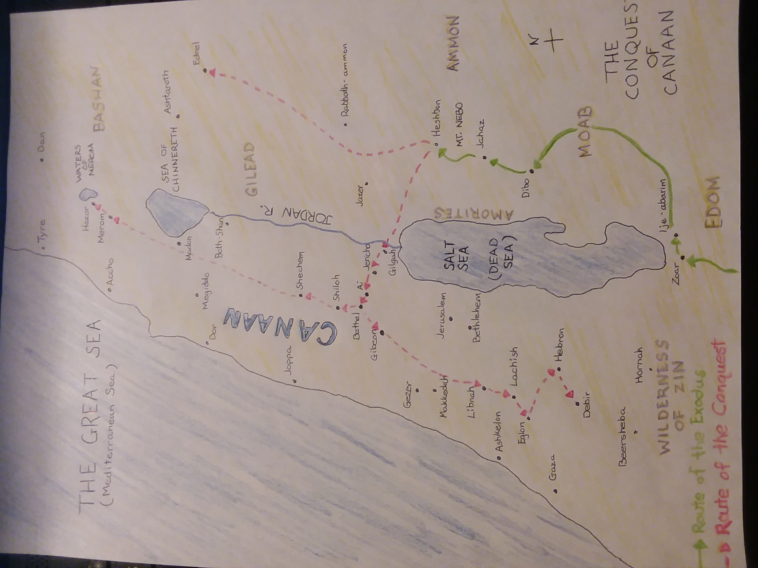

Chapter 5
Gilgal Rephaim
“Wheel of the Giants”
Gigal is mentioned 39 times in the Bible as the place where Joshua placed 12 stones in a circle from the Jordan River upon the 12 tribes crossing into the promised land. Here the people of Israel camped and observed the Passover Feast for the first time in the land that was promised to Abraham, Isaac and Jacob. Joshua circumcised the next generation of men here before taking possession of the promised land. The Jordan river was at flood stage and the priests carried the ark of the covenant on their shoulders leading the people. As the ark approached the flooded river the waters parted as they had 40 years earlier when they crossed the Red Sea. As the 12 tribes of Israel over 2 million in number crossed the Jordan River into the land of Canaan, they walked through the river on dry ground. At Gilgal, less than 10 miles from Jericho, Joshua made a circle of 12 stones representing the 12 tribes of Israel.
North of the holy site Joshua made to commemorate Israel’s crossing of the Jordan River is the land of Bashan that Og, one of the Rephaim, ruled before the army of Israel cut him down. This land is near Mt. Hermon and today is known as the Golan Heights. Near Syria, the land has often been contested and today is the location of an Israeli military base. Within the military post is an archeological megalith site known as Gilgal Rephaim (the Wheel of the Giants).
David prophetically gives a play by play of the crucifixion of Jesus hundreds of years before it occurred in the 22nd Psalm. During this prophetic song, David gives a description of the scene that to this day I have yet to hear an explanation for.

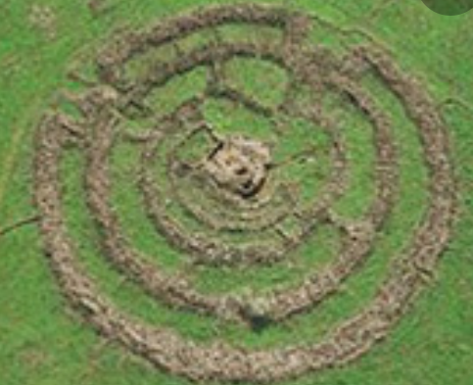

Psalm 22:12
“Many bulls surround me;
strong bulls of Bashan encircle me.”

Is it possible that those bulls encircling Jesus on the cross are the ancient giants who once ruled Bashan? It is fascinating that one of Christ’s last statements from the cross is “My God, My God, why have you forsaken me?” This is the first phrase of David’s 22nd Psalm. The Hebrew people had the psalms memorized for Sabbath worship. When Christ declared the first line of Psalm 22 in Hebrew, “Eloi, Eloi, lama sabachthani?” Each Hebrew witness to the crucifixion would have been able to quote the remainder of the psalm as the details of this prophecy unfolded before their eyes. Including the bulls of Bashan encircling the Messiah.
In the land of Bashan to this day the largest megalith in the middle east commemorates the summer solstice with perfect solar alignment. 5 rings of stone four feet high and 300 ft across is known as Gilgal Rephaim in Hebrew which translated means the wheel of the giants. Scholars call the site Israel’s Stonehenge. It is no coincidence that in the land of the Rephaim, whom Joshua defeated, a wheel of stone that is a remnant of a pagan giant religion still exists reminding us of a lost chapter of history.

Chapter 6
And the Walls Came Tumbling Down
Joshua 5:13-15 & 6:1-27
Archeologists have found the crumbled walls of Jericho northwest of the Dead Sea. Many scholars believe after excavating the area that it is the oldest walled city ever found.
Now when Joshua was near Jericho, he looked up and saw a man standing in front of him with a drawn sword in his hand. Joshua went up to him and asked, “Are you for us or for our enemies?”
“Neither,” he replied, “but as commander of the army of the LORD I have now come.” Then Joshua fell face down to the ground in reverence, and asked him, “What message does my Lord have for his servant?”
The commander of the LORD’s army replied, “Take off your sandals, for the place where you are standing is holy.” And Joshua did so.
Now Jericho was tightly shut up because of the Israelites. No one went out and no one came in.
Then the LORD said to Joshua, “See, I have delivered Jericho into your hands, along with its king and its fighting men. March around the city once with all of the armed men. Do this for six days. Have seven priests carry trumpets of rams’ horns in front of the ark. On the seventh day, march around the city seven times, with the priests blowing the trumpets. When you hear them sound a long blast on the trumpets, have all the people give a loud shout; then the wall of the city will collapse and the people will go up, every man straight in.”
So Joshua son of Nun called the priests and said to them, “Take up the ark of the covenant of the LORD and have seven priests carry trumpets in front of it.” And he ordered the people, “Advance! March around the city, with the armed guard going ahead of the ark of the LORD.”
When Joshua had spoken to the people, the seven priests carrying the seven trumpets before the LORD went forward, blowing their trumpets, and the ark of the LORD’s covenant followed them. The armed guard marched ahead of the priests who blew the trumpets, and the rear guard followed the ark. All this time the trumpets were sounding. But Joshua had commanded the people, “Do not give a war cry, do not raise your voices, do not say a word until the day I tell you to shout. Then shout!” So he had the ark of the LORD carried around the city, circling it once. Then the people returned to camp and spent the night there.
Joshua got up early the next morning and the priests took up the ark of the LORD. The seven priests carrying the seven trumpets went forward, marching before the ark of the LORD and blowing the trumpets. The armed men went ahead of them and the rear guard followed the ark of the LORD, while the trumpets kept sounding. So on the second day they marched around the city once and returned to the camp. They did this for six days.
On the seventh day, they got up at daybreak and marched around the city seven times in the same manner, except that on that day they circled the city seven times. The seventh time around, when the priests sounded the trumpet blast, Joshua commanded the people, “Shout! For the LORD has given you the city! The city and all that is in it are to be devoted to the LORD. Only Rahab the prostitute and all who are with her in her house shall be spared, because she hid the spies we sent. But keep away from the devoted things, so that you will not bring about your own destruction by taking any of them. Otherwise you will make the camp of Israel liable to destruction and bring trouble on it. All the silver and gold and the articles of bronze and iron are sacred to the LORD and must go into his treasury.”
When the trumpets sounded, the people shouted, and at the sound of the trumpet, when the people gave a loud shout, the wall collapsed; so every man charged straight in, and they took the city. They devoted the city to the LORD and destroyed with the sword every living thing in it – men and women, young and old, cattle, sheep and donkeys.
Joshua said to the two men who had spied out the land, “Go into prostitute’s house and bring her out and all who belong to her, in accordance with your oath to her.” So the young men who had done the spying went in and brought out Rahab, her father and mother and brothers and all who belonged to her. They brought out her entire family and put them in a place outside the camp of Israel.
Then they burned the whole city and everything in it, but they put the silver and gold and the articles of bronze and iron into the treasury of the LORD’s house. But Joshua spared Rahab the prostitute, with her family and all who belonged to her, because she hid the men Joshua had sent as spies to Jericho – and she lives among the Israelites to this day.
At that time Joshua pronounced this solemn oath: “Cursed before the LORD is the man who undertakes to rebuild this city, Jericho:
“At the cost of his firstborn son
Will he lay its foundations;
At the cost of his youngest
Will he set up its gates.”

So the LORD was with Joshua, and his fame spread throughout the land.

Atheists make the argument that “A Loving God” could not order the slaughter of innocent elderly, women and children. If God doesn’t exist then what standard are we holding the absent God to? My standard? Your standard? If there is no Giver of the Law then there is no law! Then the argument is made by the atheist that God can’t break his own law. Who were the people that God ordered exterminated and what were their practices? The answer to “Who did God order killed?” is the Amorites and Canaanites. The people who sacrificed their children to the god of Moleck. The idol was a brass bull that would be heated up before mothers would place their infants on the glowing searing hot idol’s arms; burning the children alive.
Proverbs 6:16-19
There are six things the LORD hates,
Seven that are detestable to him:
Haughty eyes,
A lying tongue,
Hands that shed innocent blood,
A heart that devises wicked schemes,
Feet that are quick to rush into evil,
A false witness who pours out lies
And a man who stirs up dissension among brothers.

The most innocent creature on earth is an infant. God’s righteous anger executed on the Amorites and Canaanites prevented future generations of pagan worship senselessly taking the innocent lives of their children. Also, God had sternly warned Israel not to imitate the horrific behavior of the Canaanites. It was imperative that Israel not participate in the human sacrifices of the former inhabitants of the land of Canaan.
When God made his covenant to Abram, he gave the reason why he had chosen not to give the promised land to Abram yet. Something had not happened yet.
Genesis 15:13-20
Then the LORD said to him, “Know for certain that your descendants will be strangers in a country not their own, and they will be enslaved and mistreated four hundred years. But I will punish the nation they serve as slaves, and afterward they will come out with great possessions. You, however, will go to your fathers in peace and be buried at a good old age. In the fourth generation your descendants will come back here, for the sin of the Amorites has not yet reached its full measure.”

Just as God waited for sin to reach its full measure before sending the flood, and just as God waited for sin to reach its full measure before confusing the people at the Tower of Babel, God waited for the sin of the Amorites to reach its full measure to render judgement on them and to give their land to the descendants of Abraham.

City of Ai Destroyed
Joshua Chapter 8:1-29

Then the LORD said to Joshua, “Do not be afraid, do not be discouraged. Take the whole army with you, and go up and attack Ai. For I have delivered into your hands the king of Ai, his people, his city and his land. You should do to Ai and its king as you did to Jericho and its king, except that you may carry off their plunder and livestock for yourselves. Set an ambush behind the city.”
So Joshua and the whole army moved out to attack Ai. He chose thirty thousand of his best fighting men and sent them out at night with these orders: “Listen carefully. You are to set an ambush behind the city. Don’t go very far from it. All of you be on alert. I and all those with me will advance on the city, and when the men come out against us, as they did before, we will flee from them. They will pursue us until we have lured them away from the city, for they will say, ‘They are running away from us as they did before.’ So when we flee from them, you are to rise up from ambush and take the city. The LORD your God will give it into your hand. When you have taken the city, set it on fire. Do what the LORD has commanded. See to it; you have my orders.”
Then Joshua sent them off, and they went to the place of ambush and lay in wait between Bethel and Ai, to the West of Ai – but Joshua spent that night with the people.
Early the next morning Joshua mustered his men, and he and the leaders of Israel marched before them to Ai. The entire force that was with him marched up and approached the city and arrived in front of it. They set up camp north of Ai, with the valley between them and the city. Joshua had taken about five thousand men and set them in ambush between Bethel and Ai, to the west of the city. They had the soldiers take up their positions – all those in the camp to the north of the city and the ambush to the west of it. That night Joshua went into the valley.
When the king of Ai saw this, he and all of his men of the city hurried out early in the morning to meet Israel in battle at a certain place overlooking the Arabah. But he did not know that an ambush had been set against him behind the city. Joshua and all Israel let themselves be driven back before them, and they fled toward the desert. All the men of Ai were called to pursue them, and they pursued Joshua and were lured away from the city. Not a man remained in Ai or Bethel who did not go after Israel. They left the city open and went in pursuit of Israel.
Then the LORD said to Joshua, “Hold out toward Ai the javelin that is in your hand, for into your hand I will deliver the city.” So Joshua held out his javelin toward Ai. As soon as he did this, the men in the ambush rose quickly from their position and rushed forward. They entered the city and captured it and quickly set it on fire.
The men of Ai looked back and saw the smoke of the city rising against the sky, but they had no chance to escape in any direction, for the Israelites who had been fleeing toward the desert had turned back against their pursuers. For when Joshua and all Israel saw that the ambush had taken the city against them, so that they were caught in the middle, with Israelites on both sides. Israel cut them down, leaving them neither survivors nor fugitives. But they took the king of Ai alive and brought him to Joshua.
When Israel had finished killing all the men of Ai in the fields and in the desert where they had chased them, and when every one of them had been put to the sword, all the Israelites returned to Ai and killed those who were in it. Twelve thousand men and women fell that day – all the people Ai. For Joshua did not draw back the hand that held out his javelin until he had destroyed all who lived in Ai. But Israel did carry off for themselves the livestock and plunder of this city, as the LORD had instructed Joshua.
So Joshua burned Ai and made it a permanent heap of ruins, a desolate place to this day. He hung the king of Ai on a tree and left him there until evening. At sunset, Joshua ordered them to take his body from the tree and throw it down at the entrance of the city gate. And they raised a large pile of rocks over it, which remains to this day.

Moses destroyed king Sihon of the Amorites and Og king of Bashan. Then Moses commanded Joshua to kill everything that breathed in the land of Canaan. Joshua obeyed the command of Moses and his army killed 31 kings listed in Joshua Chapter 12, as well as the Anakites (giants who were the descendants of Anak); no survivors were left. Each kingdom that Joshua’s army defeated every man, woman and child was destroyed as accounted in the scriptural record.
“For it was the LORD who hardened their hearts to wage war against Israel, so that he might destroy them totally, exterminating them without mercy, as the LORD had commanded Moses.” Joshua 11:20

Joshua documents in Joshua 11:22 that no Anakites were left in Israelite territory; only in Gaza, Gath, Ashdod did any survive. Later, David killed the last of the giants living in Canaan as we read in chapter 1 of this book.

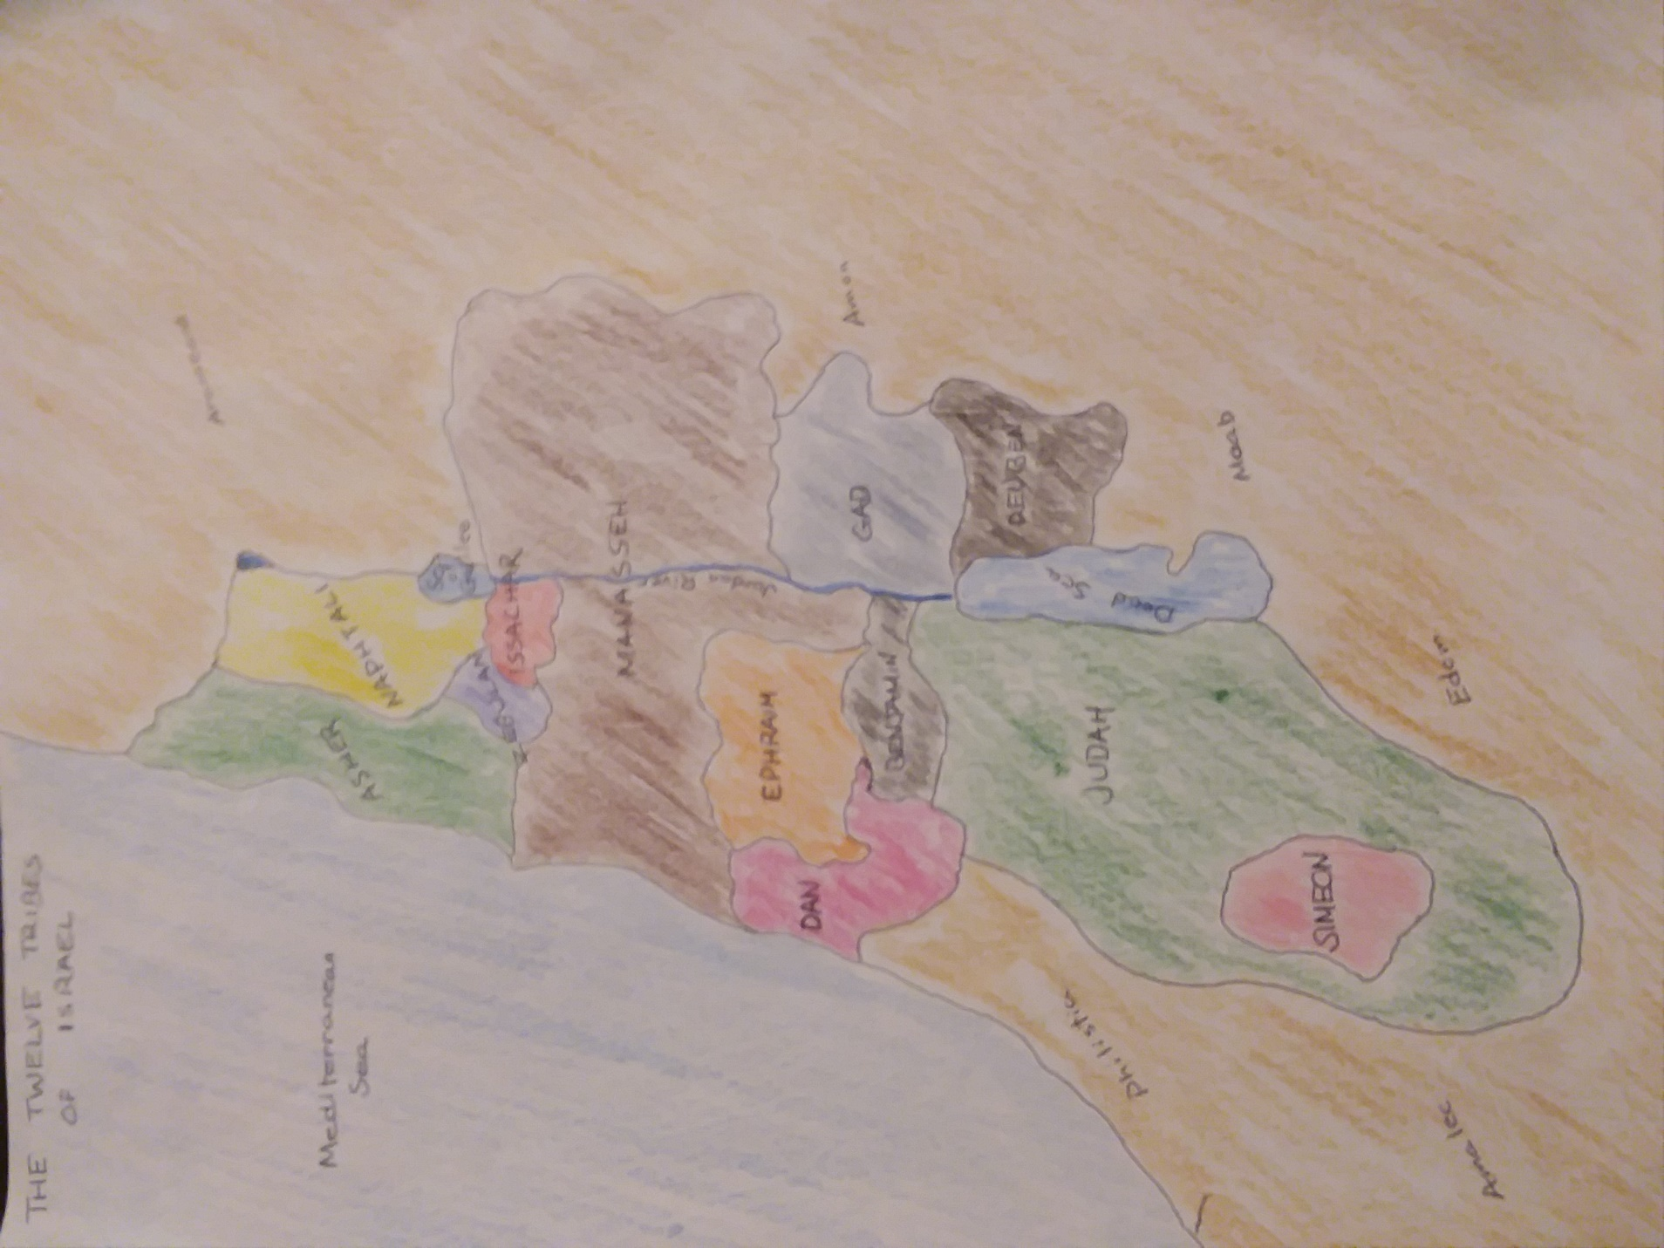

Chapter 7
Abraham’s War
Genesis 14:1-24

Continuing our study back in time, God chose a man from Ur in modern day Iraq to be the ‘Father of a multitude’. Abram or Abraham is the Father of the Hebrew people: the LORD is the God of Abraham, Isaac and Jacob. Jacob (Israel) being the father of the 12 tribes of Israel that would later inhabit the land of Canaan that had been promised to Abraham. Abraham is also the father of the ‘faithful’ Christians as Jesus of Nazareth is a direct descendant of Abraham: fulfilling God’s promise that through Abraham’s descendants the world would be blessed. The people of Islam also trace their faith back to Ishmael, Abraham’s son with his maidservant Hagar. Nearly half of the global population has a theological tie to this patriarch.
When God called Abraham to “the land he would show him”, Abraham’s nephew, Lot, went with him. Lot moved around with Abraham living in tents and managing his flocks and herds just as Abraham managed his flocks and herds. They were so blessed that the land could not sustain all of their animals living together. Abraham wisely allowed Lot to choose where he would like to live raising his flocks and herds and Abraham would go another way. Lot chose the fertile Jordan plain near Sodom and Gomorrah. Thus, Abraham took his flocks and herds to the land of Canaan on the opposite side of the Jordan River from Lot his nephew. This is where we pick up with our study in Genesis 14:1.
“At this time Amraphel king of Shinar, Arioch king of Ellasar, Kedorlaomer king of Elam and Tidal king of Goiim went to war against Bera king of Sodom, Birsha king of Gomorrah, Shinab king of Admah, Shemeber king of Zeboiim, and the king of Bela (that is, Zoar). All these latter kings joined forces in the Valley of Siddim (the Salt Sea). For twelve years they had been subject to Kedorlaomer, but in the thirteenth year they rebelled.
In the fourteenth year, Kedorlaomer and the kings allied with him went out and defeated the Rephaites in Ashteroth Kernaim, the Zuzites in Ham, the Emites in Shaveh Kitisthaim, the Emites in Shaveh Kiriathaim and the Horites in the hill country of Seir, as far as El Paran near the desert. Then they conquered the Amalekites, as well as the Amorites who were living in Hazazon Tamar.
Then the king of Sodom, the king of Gomorrah, the king of Admah, the king of Zeboiim, and the king of Bela (that is, Zoar) marched out and drew up their battle lines in the Valley of Siddim against Kedorlaomer king of Elam, Tidal king of Goiim, Amraphel king of Shinar and Arioch king of Ellasar – four kings against five. Now the Valley of Siddim was full of tar pits, and when the kings of Sodom and Gomorrah fled, some of the men fell into them and the rest fled to the hills. The four kings seized all the goods of Sodom and Gomorrah and all their food; then they went away. They also carried off Abram’s nephew Lot and his possessions since he was living in Sodom.
One who had escaped came and reported this to Abram the Hebrew. Now Abram was living near the great trees of Mamre the Amorite, a brother of Eshcol and Aner, all of whom were allied with Abram. When Abram heard that his relative had been taken captive, he called out the 318 trained men born in his household and went in pursuit as far as Dan. During the night Abram divided his men to attack them and he routed them, pursuing them as far as Hobah, north of Damascus. He recovered all the goods and brought back his relative Lot and his possessions, together with the women and the other people.
After Abram returned from defeating Kedorlaomer and the kings allied with him, the king of Sodom came out to meet him in the Valley of Shaveh (that is, the King’s Valley).
Then Melchizedek king of Salem brought out bread and wine. He was priest of God Most High, and he blessed Abram, saying,
‘Blessed be Abram by God Most High,
Creator of heaven and earth.
And blessed be God Most High,
who delivered your enemies into your hand.’
Then Abram gave him a tenth of everything.
The king of Sodom said to Abram, ‘Give me the people and keep the goods for yourself.’
But Abram said to the king of Sodom, ‘I have raised my hand to the LORD, God Most High, Creator of heaven and earth, and have taken an oath that I will accept nothing belonging to you, not even a thread or the thong of a sandal, so that you will never be able to say, “I made Abram rich.” I will accept nothing but what my men have eaten and the share that belongs to the men who went with me – to Aner, Eshcol and Mamre. Let them have their share.”

I wish to point out that the king known as Amraphel, king of Shinar (Babylon), could be Nimrod, who built the tower of Babel. Shinar is translated, Babylonia. Whether or not this is Nimrod or a later king of Babylon is of no necessity for our study.

(These 4) “kings defeated the Rephaites in Ashteroth Kernaim, the Zuzites in Ham, the Emites in Shaveh Kitisthaim, the Emites in Shaveh Kiriathaim and the Horites in the hill country of Seir, as far as El Paran near the desert. Then they conquered the Amalekites, as well as the Amorites who were living in Hazazon Tamar.

What do these 7 groups have in common? They were the clans of ‘tall people’ described by Moses in Deuteronomy 2. (See chapter 3 of the Giant Problem) The same clans of giants that Moses and Joshua exterminated in the accounts listed in Numbers, Deuteronomy and Joshua were already very well established in the land of Canaan 10 generations after the flood described in Genesis. Thousands of massive people had settled in this region. 4 kings attacked 5 kings. It is my contention that God used this opportunity to thin out the population in the land of Canaan.
Abram had been blessed tremendously to have been living as a foreigner in the land of Canaan in tents, but had 318 fighting men at his disposal to serve him in his time of need when his nephew Lot had been kidnapped. Incredibly, Abram’s small militia routed a 4 king army that had just decimated a 5 king army. Bottom line, the post flood giants were cut down significantly during this conflict. Moses and Joshua later had the army required to wipe out this problem. David later totally completed the task.
Melchizedek is one of the most mysterious individuals in the entire scripture. He is king of the ancient city of Jerusalem and also priest of God Most High. The book of Hebrews in the New Testament tells us that Jesus is the Christian’s high priest in the order of Melchizedek. Christ is prophet, priest and king; fascinatingly, so was Melchizedek. Melchizedek blessed Abram, praised God and served bread and wine which is the earliest shadow of the Lord’s Supper in the scripture. Abram gave the priest 10 percent of everything. This is the precedent for tithing. The king of Sodom made Abram an offer too good to refuse, but refuse he did. Abram knew the evil that Sodom’s kingdom indulged in and God would soon be swift with judgement.
Rewind the tape:
1.) 4 kings’ armies defeat 5 kings’ armies thinning out the population of giants in Canaan. (Abram is promised by God that his descendants will one day call this land their own.)
2.) Abram’s militia defeats the 4 king army that had just thinned out the Canaan population. He has communion with Melchizedek and gives him a tenth of his possessions while refusing the gift of the king of Sodom.
3.) Moses and Joshua exterminated the clans of giants in Canaan while conquering the land God promised Abraham, Isaac and Jacob’s descendants.
4.) David kills the last remaining giants in Canaan and establishes his throne that will one day bring salvation to the entire world.

Chapter 8
Noah Starts Over
Genesis 6:1-8

When men began to increase in number on the earth and daughters were born to them, the sons of God saw that the daughters of men were beautiful, and they married any of them they chose. Then the LORD said, ‘My Spirit will not contend with man forever, for he is mortal; his days will be a hundred and twenty years.’
The Nephilim were on the earth in those days – and also afterward – when the sons of God went to the daughters of men and had children by them. They were the heroes of old, men of renown.
The Lord saw how great man’s wickedness on the earth had become, and that every inclination of the thoughts of his heart was only evil all the time. The LORD was grieved that he made man on the earth, and his heart was filled with pain. So the LORD said, ‘I will wipe mankind, whom I have created, from the face of the earth – men and animals, and creatures that move along the ground, and birds of the air – for I am grieved that I have made them.’ But Noah found favor in the eyes of the LORD.”

These 7 verses have been debated in theological circles for the last two millennium. The ‘sons of God’ is the core of the arguments. Seminaries teach Bible students that the ‘sons of God’ is nomenclature for the sons of Seth, son of Adam and Eve. Furthermore, that the ‘daughters of men’ are the daughters of Cain, who killed his brother Abel. The theological view of many scholars is that Seth’s God fearing descendants married Cain’s descendants who did not obey God and a culture of disobedience was nurtured. This explanation is quite popular and is taught widely in today’s church studies. But where do the Nephilim come from? Giants roamed the earth because Seth’s family married Cain’s family? Really?
The term ‘sons of God’ also appears in Job 1:6:
“One day the sons of God came to present themselves before the LORD, and Satan also came with them. The LORD said to Satan, ‘Where have you come from?’
Satan answered the LORD, ‘From roaming through the earth and going back and forth in it.’

Some reject the term ‘sons of God’ stating that Jesus is the “only begotten Son of God” (John 3:16). It is essential to understand ‘sons of God’ is a Hebrew term that literally translated to English is ‘angels’. The committee of James I of England left the nomenclature ‘sons of God’ in 1611. Later translations use ‘angels’.

“On another day the sons of God came to present themselves before the LORD, and Satan also came with them. The LORD said to Satan, ‘Where have you come from?’
Satan answered the LORD, ‘From roaming through the earth and going back and forth in it.’ Job 2:1-2

Other Bible appearances: Job 38:7, Deuteronomy 32:8, Psalms 29:1, Psalms 82:6, Psalms 89:6 and Daniel 3:25. Clearly each reference listed in the Scripture refers to angels.

Many make the argument that Jesus said that ‘angels can’t marry.’ The Gospel of Matthew Chapter 22:30 records Jesus saying,
“At the resurrection people will neither marry nor be given in marriage; they will be like the angels in heaven.”
The angels in heaven have remained obedient to the LORD whom they serve, so no, they do not marry!
But consider what Jude says in the 6th and 7th verses of his New Testament letter:
“And the angels who did not keep their positions of authority but abandoned their own home – these he has kept in darkness, bound with everlasting chains for judgment on the great Day. In a similar way, Sodom and Gomorrah and the surrounding towns gave themselves up to sexual immorality and perversion. They serve as an example of those who suffer the punishment of eternal fire.”
If these angels abandoned their positions in heaven and engaged in sexual immorality and perversion “in a similar way” that Sodom and Gomorrah did, then it is possible that these angels took wives as Genesis 6 indicates. Peter also mentions how God chained the angels who sinned in Tartarus and compares the judgement of the flood to the judgement of Sodom and Gomorrah in 2 Peter 2:4-6. Both the judgements of the flood and Sodom and Gomorrah were the result of perverse, unnatural sexual sin. Just as it was not the purpose of man to fornicate in the fashion that was acceptable in Sodom and Gomorrah, it was not the purpose of the angels to sin sexually with the daughters of men. Their children were the Nephilim and the world suffered because of this blatant disobedience to the Creator.
The church abandoned this view by the second century A.D. in the Letters attributed to Clement as well as Augustine of Hippo. But with the discovery of the Dead Sea Scrolls in 1947 in the Qumran Caves in the Judaean Desert scholars have been able to translate Hebrew text over 2,000 years old. This preserved text shows the sons of God recorded in the canonized Hebrew scriptures as well as the texts from the Second Temple Period which later were not canonized in the Bible. However, the Bible refers to these uncanonized texts such as the Book of Jasher (2 Samuel 1:18, Joshua 10:13 & 2 Timothy 3:8) and the Book of Enoch (Jude 4-6 & 13-15, 2 Peter 2:4 & 3:13, John 7:38) as references. Christ and the Apostles quoted these books as well as the prophet Samuel and Joshua. These books have much information about the world before the flood of Noah and afterward. Inside of the Book of Enoch is the work the Book of Giants. This text, even though was not canonized by the Roman Catholic Church, was preserved by the Essenes in Israel just before, during and shortly after the time Christ was in the land. My argument is this: if the prophets, apostles and Christ himself quoted from this text it could give us insight to some scripture that is difficult to understand. (The Book of Enoch, Jubilees, etc. indicates that the fallen angels were the fathers of the Nephilim giants.) Jude and 2 Peter have identical occurrences of the severe punishment for this sin against God.
Titus Flavius Josephus, the first century Hebrew historian, stated in Antiquities of the Jews:
“…many angels of God accompanied with women and begat sons that proved unjust, and despisers of all that was good, on account of the confidence they had in their own strength; for the tradition is, that these men did what resembled the acts of those whom the Grecians call giants.”

Genesis 6:5-8 states,
“The Lord saw how great man’s wickedness on the earth had become, and that every inclination of the thoughts of his heart was only evil all the time. The LORD was grieved that he made man on the earth, and his heart was filled with pain. So the LORD said, ‘I will wipe mankind, whom I have created, from the face of the earth – men and animals, and creatures that move along the ground, and birds of the air – for I am grieved that I have made them.’

The human race had been compromised by the sin of those who would eternally be cut off from the blessing of God. Look at what Peter says about the eternal punishment in the New Testament.

I Peter 3:18-22
“For Christ died for sins once for all, the righteous for the unrighteous, to bring you to God. He was put to death in the body but made alive by the Spirit, through whom also he went and preached to the spirits in prison who disobeyed long ago when God waited patiently in the days of Noah while the ark was being built. In it only a few people, eight in all, were saved through water, and this water symbolizes baptism that now saves you also – not the removal of dirt from the body but the pledge of a good conscience toward God. It saves you by the resurrection of Jesus Christ, who has gone into heaven and is at God’s right hand – with angels, authorities and powers in submission to him.

Thousands of years after the sin was committed, Christ went to the spirits in prison and preached his victory over them. Salvation was now available to all mankind; whosoever will claim it, but no such good news for those chained spirits who chose their path long ago.

2 Peter 2:4-5
“For if God did not spare angels when they sinned, but sent them to Tartarus, putting them into gloomy dungeons to be held for judgement; if he did not spare the ancient world when he brought the flood on its ungodly people, but protected Noah, a preacher of righteousness, and seven others; if he condemned the cities of Sodom and Gomorrah by burning them to ashes, and made them an example of what is going to happen to the ungodly;”

Noah and his three sons, Shem, Ham and Japheth and their wives entered the ark that God had commanded Noah to construct, along with male and female of every animal and 7 pairs of every clean animal and seven pairs of every bird. In the six hundredth year of Noah’s life, on the seventeenth day of the second month all the springs of the deep and the floodgates of the heavens were opened. The rain fell on the earth for forty days and forty nights. The waters covered the mountains to a depth of more than 20 feet. The waters flooded the earth one hundred and fifty days. The ark came to rest on the mountains of Ararat. God set the rainbow in the clouds as the sign of his promise to never destroy the earth with water again.
The oldest recovered clay tablet of human writing is the Sumerian Epic of Gilgamesh. In this story is a tale of an old man with 3 sons and their wives in a large boat with many animals surviving a flood. The Chinese tell a similar story, as do the indigenous peoples of North and South American. Many scholars dismiss these tales as proof that Noah’s story is made up. On the contrary, so many cultures tell a version of this epic tale because everyone who is on the earth today is a descendant of the eight people who survived the flood in the ark God perfectly designed!

Let’s review:
- Sons of God produced Nephilim and the earth was filled with violence. The Nephilim were on the earth in those days and also afterward.
2.) God destroyed the entire earth except who and what was on the ark.
3.) 4 kings’ armies defeat 5 kings’ armies thinning out the population of giants in Canaan. (Abram is promised by God that his descendants will one day call this land their own.)
4.) Abram’s militia defeats the 4 king army that had just thinned out the Canaan population. He has communion with Melchizedek and gives him a tenth of his possessions while refusing the gift of the king of Sodom.
5.) Moses and Joshua exterminated the clans of giants in Canaan while conquering the land God promised Abraham, Isaac and Jacob’s descendants.
6.) David kills the last remaining giants in Canaan and establishes his throne that will one day bring salvation to the entire world.

Chapter 9
Israel’s Destruction
Jeremiah 32:26-44

Then the word of the LORD came to Jeremiah: “I am the LORD, the God of all mankind. Is anything too hard for me? Therefore, this is what the LORD says: I am about to hand this city over to the Babylonians and to Nebuchadnezzar king of Babylon, who will capture it. The Babylonians who are attacking this city will come in and set it on fire; they will burn it down, along with the houses where the people provoked me to anger by burning incense on the roofs to Baal and by pouring out drink offerings to other gods.
The people of Israel and Judah have done nothing but evil in my sight from their youth; indeed, the people of Israel have done nothing but provoke me with what their hands have made, declares the LORD. From the day it was built until now, this city has so aroused my anger and wrath that I must remove it from my sight. The people of Israel and Judah have provoked me by all the evil they have done – they, their kings and officials, their priests and prophets, the men of Judah and the people of Jerusalem. They turned their backs to me and not their faces; though I taught them again and again, they would not listen or respond to discipline. They set up their abominable idols in the house that bears my Name and defiled it. They built high places for Baal in the Valley of Ben Hinnom to sacrifice their sons and daughters to Molech, though I never commanded, nor did it enter my mind, that they should do such a detestable thing and so make Judah sin.
You are saying about this city, ‘By the sword, famine and plague it will be handed over to the king of Babylon, but this is what the LORD, the God of Israel, says: I will surely gather them from all the lands where I banish them in my furious anger and great wrath; I will bring them back to this place and let them live in safety. They will be my people, and I will be their God. I will give them singleness of heart and action, so that they will always fear me for their own good and the good of their children after them. I will make an everlasting covenant with them: I will never stop doing good to them, and I will inspire them to fear me, so that they will never turn away from me. I will rejoice in doing them good and will assuredly plant them in this land with all my heart and soul.
This is what the LORD says: As I have brought all this great calamity on this people, so I will give them all the prosperity I have promised them. Once more fields will be bought in this land of which you say, ‘It is a desolate waste, without men or animals, for it has been handed over to the Babylonians.’ Fields will be bought for silver, and deeds will be signed, sealed and witnessed in the territory of Benjamin, in the villages around Jerusalem, in the towns of Judah and in the towns of the hill country, of the western foothills and of the Negev, because I will restore their fortunes, declares the LORD.”

The prophet Jeremiah was imprisoned by the king of Judah, Zedekiah, for uttering such a damning prophecy against Jerusalem. The weeping prophet told the king why God had executed judgement on them: they had disobeyed the command God had given Moses before the tribes of Israel entered the promised land generations before.

Deuteronomy 18:9-14
“When you enter the land the LORD your God is giving you, do not learn to imitate the detestable ways of the nations there. Let no one be found among you who sacrifices his son or daughter in the fire, who practices divination or sorcery, interprets omens, engages in witchcraft, or casts spells, or who is a medium or spiritist or who consults the dead. Anyone who does these things is detestable to the LORD, and because of these detestable practices the LORD your God will drive out those nations before you. You must be blameless before the LORD your God.
The nations you will dispossess listen to those who practice sorcery or divination. But as for you, the LORD your God has not permitted you to do so.”

A familiar story about Israel’s falling away from the Lord is the prophet Elijah killing the 450 prophets of Baal on Mount Carmel. Queen Jezebel ordered Elijah to be killed as he had killed the prophets of her god. Israel had not obeyed the Lord by avoiding the practices of the Canaanites!
Jeremiah also prophesied that Benjamin and Judah would once again live in this land fulfilling God’s promise of an everlasting covenant. From the tribe of Judah, from David’s family the Son of God would come!

Chapter 10
Timing is Everything

But when time had fully come, God sent his Son, born of a woman, born under law, to redeem those under law, that we might receive the full rights of sons. Because you are sons, God sent the Spirit of his son into our hearts, the Spirit who calls out, “Abba, Father.” So you are no longer a slave, but a son; and since you are a son, God has made you also an heir. Galatians 4:4-7

Christ was born around 4 B.C. during the reigns of Cesar Augustus Emperor of Rome, Herod the Great King of Judea, and Quirinius Governor of Syria. Have you ever asked the question, “Why did Christ come when he did?”

In him we have redemption through his blood, the forgiveness of sins, in accordance with the riches of God’s grace that he lavished on us with all wisdom and understanding. And he made known to us the mystery of his will according to his good pleasure, which he purposed in Christ, to be put into effect when the times will have reached their fulfillment – to bring all things in heaven and on earth together under one head, even Christ. Ephesians 1:7-10

- Nehemiah Rebuilds the Walls of Jerusalem

Around the year 444 BC Nehemiah was given the full blessing of Artaxerexes, King of Persia to rebuild the city walls of Jerusalem. Nehemiah completed this enormous task in a mere 52 days. As a result, 42,360 Israelites returned to the safety within the city walls. Ezra the scribe read the law to the people and the tribes of Judah and Benjamin resumed sanctified living under the Law of Moses.

- Herod the Great Rebuilds the Temple of Jerusalem
Around 20 BC Herod the Great began renovating the temple that had been constructed by Solomon 600 years earlier. The Babylonians had destroyed and looted the great temple of Solomon and Herod had ambition of making a name for himself by rebuilding the sacred place of worship.

In 4 BC Joseph and Mary took the Christ child to be circumcised at the temple 8 days after his birth in nearby Bethlehem. It’s a marvelous coincidence that Herod’s renovation was completed just in time.
Three decades later Christ taught on the temple mount and offered himself as the Lamb of God that takes away the sin of the world.
But now he has appeared once for all at the end of the ages to do away with sin by the sacrifice of himself. Hebrews 9:26

- Alexander the Great Conquers 3 Continents Leaving Behind the Greek Language

June of 323 BC a 32 year old conqueror mysteriously died in the palace of Nebuchadnezzar II. Alexander had conquered most of the known world in a very short amount of time. His empire didn’t last long but he left behind his written language. Greek became the unified academic language of 3 continents. 3 centuries later the entire New Testament was written in Greek so everyone could understand no matter where their geographical situation was. Furthermore, the consistency of one meticulous language being the exclusive tongue of the New Testament is tremendously accommodating when studying the exegesis of the Bible. Imagine if all 27 books would have been written in different languages. Greek provided transparency that transcended the generations.

This is good, and pleases God our Savior, who wants all men to be saved and to come to a knowledge of the truth. For there is one God and one mediator between God and men, the man Christ Jesus, who gave himself as a ransom for all men – the testimony given in its proper time. I Timothy 2:3-6

- Rome constructs roads and bridges to every city in the empire
By the time the apostles and missionaries of Christ began to spread the gospel in the first century AD, the Roman Empire had constructed roads and bridges to every city in order to mobilize their army. In effect, what was accomplished was the expedition of the gospel to all people in the known world.
A faith and knowledge resting on the hope of eternal life, which God, who does not lie, promised before the beginning of time, and at his appointed season he brought his word to light through the preaching entrusted to me by the command of God our Savior; Titus 1:2-3

Christ came at the perfect moment to have maximum impact in the world. This is a profound mystery how absolutely everything coordinated perfectly so that billions have come to know that Jesus of Nazareth existed.

Let’s review the order of events:
- Sons of God produced Nephilim and the earth was filled with violence. The Nephilim were on the earth in those days and also afterward.
2.) God destroyed the entire earth except who and what was on the ark.
3.) 4 kings’ armies defeat 5 kings’ armies thinning out the population of giants in Canaan. (Abram is promised by God that his descendants will one day call this land their own.)
4.) Abram’s militia defeats the 4 king army that had just thinned out the Canaan population. He has communion with Melchizedek and gives him a tenth of his possessions while refusing the gift of the king of Sodom.
5.) Moses and Joshua exterminated the clans of giants in Canaan while conquering the land God promised Abraham, Isaac and Jacob’s descendants.
6.) David kills the last remaining giants in Canaan and establishes his throne that will one day bring salvation to the entire world.
7.) Israel is exiled out of the land of Canaan because they worshiped Baal just as the Canaanites did.
8.) Christ came from the line of David in the fullness of time.

Chapter 11
Days of Noah

It is fascinating to look at the list of the first ten generations before the flood following the ancestry to Noah and then translate the meaning of each man’s name. When you list each man in order and then list the meanings of their names in order you read the following:

Genealogy Meaning
Adam man
Seth anointed
Enosh mortal
Kenan sorrow
Mahalalel the Blessed God
Jared shall come down
Enoch teaching
Methuselah his death shall bring
Lamech the despairing
Noah rest

Do you see the Gospel message or is that a coincidence?

It is difficult to comprehend how corrupt the world became during the time of the Nephilim that God’s heart was sorry He created the earth and destroyed it. Violence ruled the earth and blood covered it. Jesus is the salvation that God gave mankind to be redeemed.
In the Gospel of Matthew the 24th Chapter verses 36-41 Jesus gives signs for the apocalypse:
“No one knows about the day or hour, not even the angels in heaven, nor the Son, but only the Father. As it was in the days of Noah, so it will be at the coming of the Son of Man. For in the days before the flood, people were eating and drinking, marrying and giving in marriage, up to the day Noah entered the ark; and they knew nothing about what would happen until the flood came and took them all away. That is how it will be at the coming of the Son of Man. Two men will be in the field; one will be taken and the other left. Two women will be grinding with a hand mill; one will be taken and the other left.”

When Christ returns the world will not be prepared. For if they were prepared for their judgement they would repent. Rather, the world will think Christ is not coming, thus it will be a dreadful day as the prophet Joel foretold. The faithful, however, will watch and wait each day for Christ to return and this will be a glorious day for those who are ready.

Chapter 12
Native American Stories

Many North American tribes tell stories of giants who had to be fought. Lovelock Cave in Nevada is a well documented account of such a conflict. In a 1931 article published in the Nevada Review-Miner, two giant skeletons had been found buried in a dry lake bed close to Lovelock, Nevada. The over-sized remains measured 8.5ft and 10ft in height and were mummified in a manner similar to the ancient Egyptians. The Paiute tribe in the area tells a story of their people fighting off giant redhaired cannibals that they called Si-Te-Cah. After seeking help from area tribes, the native Americans pushed the giants into Lovelock Cave. The Paiute people ultimately set the mouth of the cave on fire killing all of the Si-Te-Cah inside.
The plains Indians spoke the greeting, “Howgh” while showing their right hand. This was to remove any suspicion that a stranger might have six fingers on a hand. Polydactyls are a characteristic of giants; these traits are told in legend all over the world. The rest of us simply waive showing our digits or shake hands! Native Americans tell stories of six fingered, red headed, man eating giants.
The Hopi, Navajo, Pawnee, Apache, Pima, as well as many other tribes teach that giants once roamed the earth devouring all creation but the Creator sent a flood to destroy the giants. Again, all these tribes teach that the Creator sent a flood for the purpose of killing the giants!
In his 1825 book entitled, Six Nations, Tuscarora tribe member David Cusick states that when the Great Spirit made the people, some of them became giants.
While rafting the Colorado River G. E. Kincaid discovered a series of tunnels containing the remains of 9 feet skeletons as well as massive tools and weapons in 1909. The area is restricted to the public to this day by the United States Government. About 20 years later, nearby this discovery, on the Arizona-Nevada-California border similar discoveries were reported but were not published until 1947.

List of tribes and their names for giants
Apache Big Owl Man
Hopi Cheveyo Kachina
Shoshone Dzoavits
Chickasaw Lofa
Algonquian Ice Giants
Creek Kolowa
Wampanog Maushop
Choctaw Shampe
Cherokee Stoneclad
Iroquois Stone Coat
Seminole Tall Man
Cree Witiko
Wabanaki Kee-Wakw

Chapter 13
Abraham Lincoln’s Address to Congress

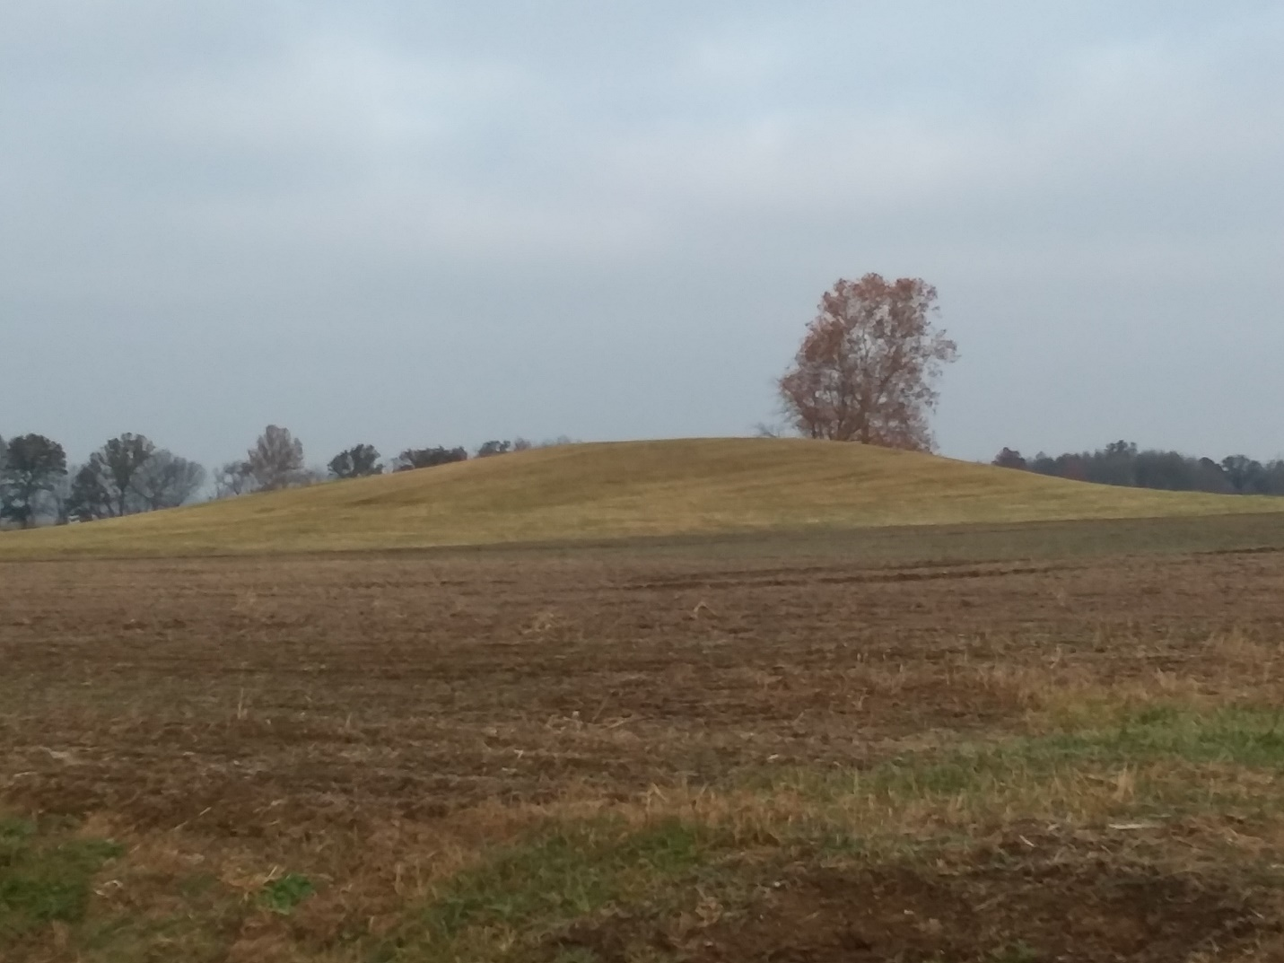
Pictured is a burial mound in Fairplay Township near Switz City, IN.

Abraham Lincoln gave an address near Niagara Falls in 1848:
“But still there is more. It calls up the indefinite past. When Columbus first sought this continent – when Christ suffered on the cross – when Moses led Israel through the Red Sea – nay, even, when Adam first came from the hand of his Maker- then as now, Niagara was roaring here. The eyes of that species of extinct giants, whose bones fill the mounds of America, have gazed on Niagara, as ours do now. Contemporary with the whole race of men, and older than the first man, Niagara is strong, and fresh to-day as ten thousand years ago. The Mammoth and Mastodon – now so long dead, that fragments of their monstrous bones, alone testify, that they ever lived, have gazed on Niagara.”

Lincoln listed common knowledge and well-known characters from history: Columbus, Christ, Moses, Adam, Mammoth and Mastodon and giants. What? That’s right, the man who would be the 16th president of the United States of America referred to a species of giants whose bones fill the mounds of America. Why on earth would he say something so outlandish? Because it wasn’t outlandish. Americans had been reading about what had been discovered in the mounds of this land for many years.
Below are just a few examples of the reports that were common not that long ago. Good sources with reliable reporting.
January 14, 1870 the Ohio Democrat published that a giant was unearthed in a mound near West Hickory with an enormous iron helmet and a nine feet long sword. The giant was said to be around 18 feet tall.
February 8, 1876 the New York Times published that 3 skeletons each 9 feet tall were found in a vault in a cave near Louisville, Kentucky.
July 14, 1880 the Marion Daily Star published that in Muskingum County, Ohio a male skeleton measuring 9 feet and a female skeleton measuring 8 feet were found in a burial mound. Clay tablets were also found with unidentified script.
February 9, 1890 the New York Times published that giant skeletons were being observed by the public in May’s Landing, New Jersey
June 27, 1885 the Philadelphia Times published that 150 giant skeletons were found in a cave near the Pennsylvania/New York state line.
April 5, 1886 the New York Times published that the day before in Carterville, Georgia a flood receded exposing giant bones and skulls.
September 26, 1889 the Cincinnati Courier Gazette published that in a mound in southern Ohio a giant skeleton was excavated along with a large panther skeleton.
August 27, 1891 the New York Sun published that a skeleton measuring 8 and a half feet in length was discovered near Salt Lake City, Utah.
December 20, 1897 the New York Times published that a nine feet tall skeleton was discovered in a burial mound near Maple Creek, Wisconsin.
January 17, 1899 the Middletown Signal published that a skeleton measuring 8 feet 1 and ½ inch was discovered near Miamisburg, Ohio.
February 11, 1902 the New York Times published that Archeologists were examining giant skeletons that had been unearthed in New Mexico.
May 4, 1908 the New York Times published that a cave in Mexico contained over 200 skeletons of men over 8 feet in height.
July 14, 1916 the New York Times published that scientists had unearthed giant skeletons in a burial mound that were 700 years old.
January 7, 1940 the San Antonio Express published that WPA workers had unearthed giant human skulls.

Many more newspaper articles exist. But where have all the bones gone? In the United States, the Smithsonian Institute governs all such finds. Each example I provided above had something in common. The Smithsonian Institute confiscated every find: all of them. Today it is a federal crime to unearth a burial mound. Moreover, if someone unintentionally unearths a skeleton the Smithsonian will take control of the site immediately.

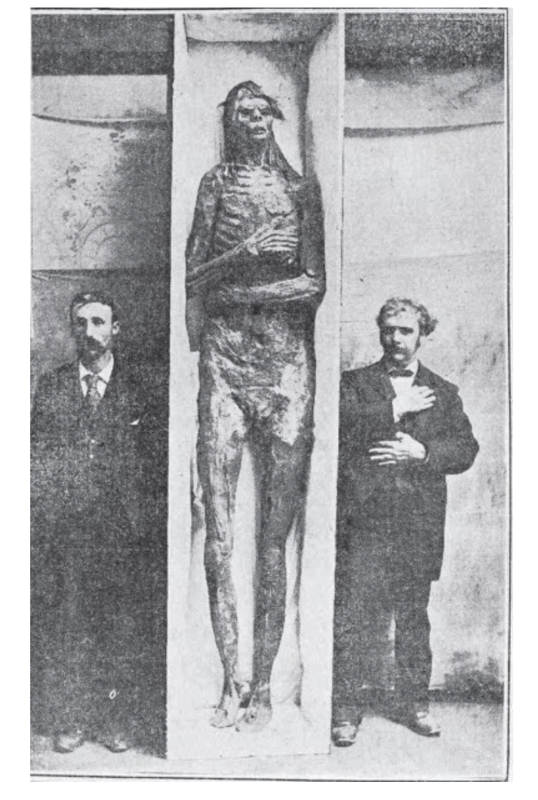

October 7, 1895 The World published that a skeleton was recovered. They also provided this famous photo.
The Smithsonian Institute paid $500.00 for the remains pictured here (nearly $15,000 in today’s money). This fellow is the “San Diego Giant”. He must have missed the bus when the Giants played the Padres.

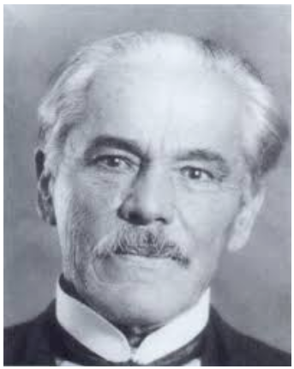
In 1903, the Smithsonian, under the leadership of Ales Hrdlicka, began discrediting every report of human giant bones ever reported. His motivation for discrediting ancient archeological digs was due to their conflict with his theory of human colonization of the American continent. Hrdlicka is the source of the idea that Asian migrants walked across a land bridge in the Bering Strait a mere 3,000 years ago resulting in the millions of Native Americans in North and South America. This theory has been disproved entirely in more recent years. 1.) The land bridge that Hrdlicka claimed existed 3,000 years ago connecting Siberia and Alaska did not exist. 2.) It has been determined that Native Americans inhabited both North and South America long before 3,000 years ago. 3.) It has been determined that many groups traveled to the American continents via maritime vessels. 4.) Conclusive DNA science proves migrations to South America had nothing to do with a possible land bridge connecting Asia and North America. Nonetheless, the 40 year tenure of Ales Hrdlicka as curator of Anthropology led the academic discipline the wrong direction at 100 miles per hour. The Smithsonian’s bias to promote Hrdlicka’s ridiculous theories compromised countless archeological discoveries that objectively challenged him. Academia from doctoral institutions all the way down to elementary school text books presented Hrdlicka’s doctrines. Unfortunately, the current official position of the Department of Anthropology at the Smithsonian Institute is that no bones have ever been found proving that giant people once inhabited the earth. The narrative that giants did not exist is alive and well.

Chapter 14
Flavius Josephus

The world’s most reliable historian from the 1st century A.D. was a Jewish Roman citizen named Flavius Josephus who lived from 37 A.D - 100 A.D. In his work Antiquities of the Jews 3 we read:
“…many angels of God accompanied with women and begat sons that proved unjust, and despisers of all that was good, on account of the confidence they had in their own strength; for the tradition is, that these men did what resembled the acts of those whom the Grecians call giants.”

Because of Josephus’ testimony in the 1st century we have the accurate traditions and history of the Hebrew people at the time of Christ. According to Josephus, the view of the Hebrew people is that the ‘sons of god’ were originally translated ‘angels’. Also, the angels married women who had sons whom the Greeks called giants. This testimony makes sense of our research.

He continues in book 5 Chapter 2:
“[They] removed their camp to Hebron; and when they had taken it, they slew all the inhabitants. There were till then a race of giants, who had bodies so large, and countenances so entirely different than other men, that they were surprising to the sight, and terrible to the hearing. The bones of these men are still shown to this very day, unlike to any credible relations of other men.”

Again, his testimony of the factual existence of giants in the land of Canaan and their characteristics. I especially find fascinating the testimony that the bones of these giants were still on display for the next generation to see and learn about. The Hebrew Rabbis no doubt used visual aids when teaching the historical accounts of Israel. Today, such an exhibit would be esteemed in the British Museum.
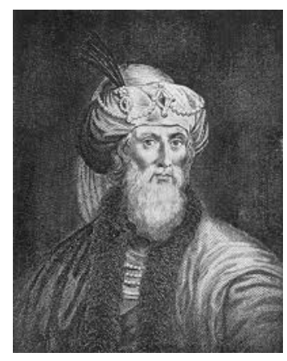

A special thanks to Mrs. Lanora Satterfield from Lawrenceville, IL who gifted me with my very own copy of the works of Flavius Josephus. It is my most valuable publication I have from the 19th century in my personal library.

Chapter 15
Baalbek
Amos 2:9

In modern day Lebanon, in the ancient land of the Canaanites, is the prehistoric city of Baalbek, named for the god Baal. The Romans revered the ancient temple of Jupiter that some ruins still stand today. Roman Emperors made the trip to the far away temple to consult the oracles there. Fascinatingly, tradition teaches that the temple is much older than the Roman era. Nimrod, King of Babylon is said to have ordered giants to build the colossal structure.

“I destroyed the Amorite before them,
Though he was tall as the cedars
And strong as the oaks.
I destroyed his fruit above
And his roots below.” -Amos 2:9

Coincidentally, the LORD compares the giant Amorites to the cedars. Cedars are the famous species of tree that grows in the forest of Lebanon.
.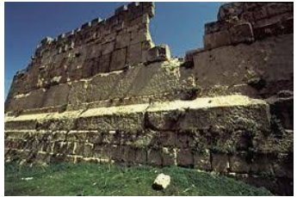
Each large stone weighs 800 tons and was quarried 1 mile from the temple structure.

The stone of the pregnant woman is the largest single cut stone in the world. It is 40 times heavier than the stones at Stonehenge weighing in at well over 1,000 tons.
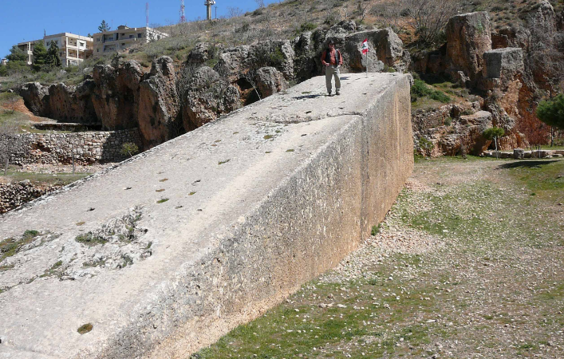

In the Epic of Gilgamesh the setting is a great forest of cedars. The largest such forest is near the Baalbek site in Lebanon. Many scholars think the Sumerian story is about Nimrod.
The larger stones were quarried and placed well before the Romans ruled the land. The god Baal, for whom the site is named, is the source of much controversy in the Old Testament of the Bible. God commanded Israel to not worship him as the Canaanites did: they disobeyed God’s command.

Chapter 16
Nimrod
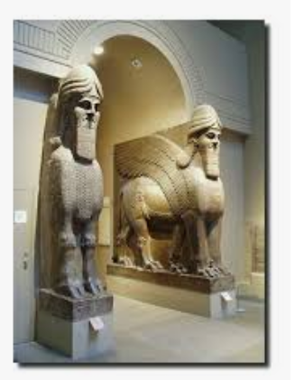
Nimrod is exhibited in the British Museum in London. This powerful ancient leader put many things in motion for the human existence.

Genesis 10:6-11
“The sons of Ham:
Cush, Mizraim, Put and Canaan.
The sons of Cush:
Seba, Havilah, Sabtah, Raamah and Sabteca.
The sons of Raamah:
Shebah and Dedan.
Cush was the father of Nimrod, who grew to be a mighty warrior on the earth. He was a mighty hunter before the LORD; that is why it is said, ‘Like Nimrod, a mighty hunter before the LORD.’ The first centers of his kingdom were Baylon, Erech, Akkad and Calneh, in Shinar. From that land he went to Assyria, where he built Nineveh, Rehoboth Ir, Calah and Resen, which is between Nineveh and Calah; that is the great city.

After the waters receded from the earth Shem, Ham and Japheth and their families spread throughout the earth. Who, what and where are recorded in the Table of Nations in the 10th Chapter of Genesis. Ham, was the father of 4 sons who were the fathers of many nations. From Ham’s sons came Egypt, Babylon and Canaan. Ham’s son Cush was the father of Nimrod, king of Babylon. This powerful king was the great grandson of Noah.
Three times in the table of nations in Genesis it is reiterated that Nimrod was a mighty warrior, mighty hunter and again a mighty hunter. Mighty is the emphasis. The occult traces its beginnings to Nimrod. Somehow, in an evil manner, Nimrod ‘became’ mighty. The temple of Jupiter in Baalbek, Lebanon is said to have been constructed by giants under the authority of Nimrod. Note that Baalbek is named for Baal. Baal is said to be Nimrod.

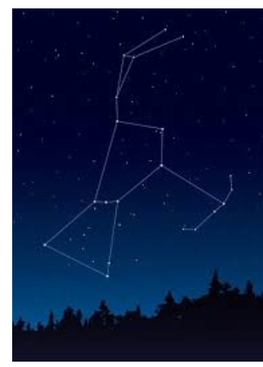
Orion is Likely the Greek Mythological interpretation of Nimrod of the Bible. Pictured Above is the “Mighty Hunter”

It is fascinating to note that the Pyramids of Giza are in the exact formation of Orion’s Belt and the ancient Sumerians claim it is from these stars where creation began.
Many cultures trace their beginnings to Nimrod and his knowledge and power.

God Thwarts Nimrod
Modern day Iraq is the home of the ancient city of Babylon where the massive tower was constructed. Satellite technology has revealed the exact location of the foundation.
Genesis 11:1-9
“Now the whole world had one language and a common speech. As men moved eastward, they found a plain in Shinar and settled there.
They said to each other, ‘Come let’s make bricks and bake them thoroughly.’ They used brick instead of stone, and tar for mortar. Then they said, ‘Come, let us build ourselves a city, with a tower that reaches to the heavens, so that we may make a name for ourselves and not be scattered over the face of the whole earth.’
But the LORD came down to see the city and the tower that men were building. The LORD said, ‘If as one people speaking the same language they have begun to do this, then nothing they plan to do will be impossible for them. Come, let us go down and confuse their language so they will not understand each other.’
So the LORD scattered them from there over all the earth, and they stopped building the city. That is why it was called Babel – because there the LORD confused the language of the whole world. From there the LORD scattered them over the face of the whole earth.

Epic of Gilgamesh
The most ancient clay tablet ever discovered is the Sumerian story of Gilgamesh. This epic hero fits the description of the great Nimrod. The story tells of an old man, his 3 sons, their wives and many animals surviving a flood on a large ship. Remember, Nimrod is the great grandson of Noah and the flood would have been in the minds of everyone in that generation. Gilgamesh became a mighty warrior and sought out to fight the one responsible for the great flood. Like Nimrod, Gilgamesh is a tamer of animals.
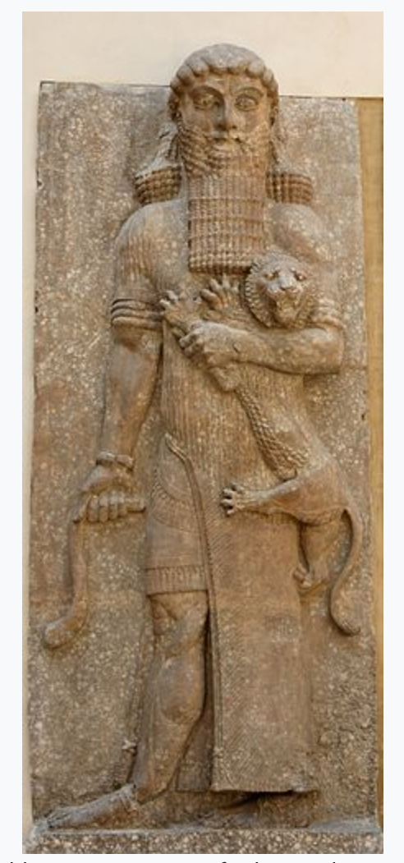
Many scholars think Gilgamesh was indeed Nimrod to the Sumerians and Orion was Nimrod to the Greeks. How interesting that at the Tower of Babel God stopped Nimrod’s construction and confused the languages of men. Now the story is told in different languages all over the world.

Chapter 17
Maximinus Thrax
Emperor of Rome
235-238 AD

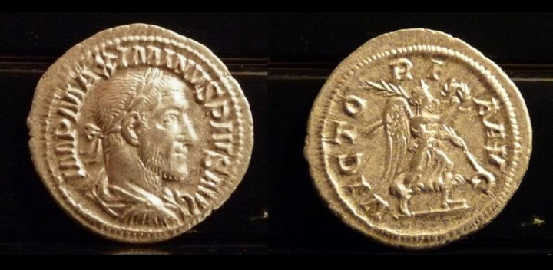
This Roman Emperor during the 3rd Century A.D. was 8 feet 6 inches tall. This height is larger than anyone known living today, yet the Emperor’s height is a matter of historical record!

Chapter 18
Walking With the Dinosaurs

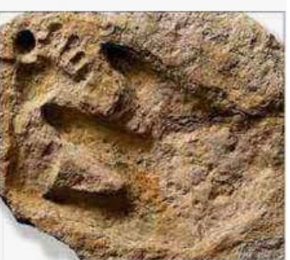

This fossil recovered from a riverbed near Glen Rose, Texas is impossible according to the textbooks. Dinosaurs were on the Earth 200 million years ago while mankind has only been here for thousands of years. Nonetheless, the reason the dino print looks small is because the human print is a size 16 shoe. This sample is one of dozens that appear in the Paluxy River.
People argue that dinosaurs are not found mentioned in the Bible. This is true; the word dinosaur was not formed until the 19th century while the Bible’s last entry was penned during the 1st century A.D. Thus when the Bible was written the word dinosaur had not been invented yet. However, the ancient story of the book of Job describes the behemoth and the leviathan in detail as creatures that Job would have been familiar with. These creatures would be considered the ‘thunder lizards’ of paleontologist nomenclature today. In years gone by people call such creatures dragons. The same cultures that tell giant tales have dragon stories as well!

Chapter 19
Around the World

Peru and Bolivia
Inca traditions teach that giants who were powerful and wise once ruled until they violently fought each other before a flood destroyed them all. Tour guides in Peru and Bolivia proclaim that the Inca built ancient cities such as Puma Punku and Machu Picchu, but the Incas never took credit for this megalithic architecture.
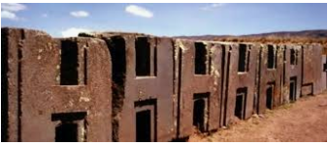
“H” blocks of Puma Punku

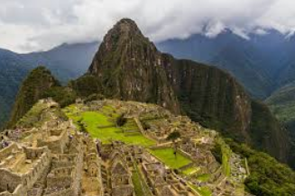
Machu Picchu is at an elevation of 7,972 ft while Cusco is at an elevation of 11,152 ft above sea level.

China
Ramparts of Gog and Magog is a name given to the Great Wall of China. Could it be that the wall once kept giants from invading China?
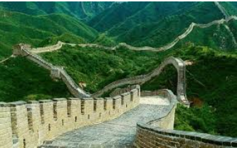
Many consider Russia as Magog mentioned in the Bible. President Ronald Reagan had this view and stated it publicly.

An ancient fossilized footprint was discovered in Guizhou, China in 2016. The human footprint is 24 inches long.

Britain
In Wales it has been told that sledgehammers were discovered in the world’s largest prehistoric copper mine that weighed 60 pounds.
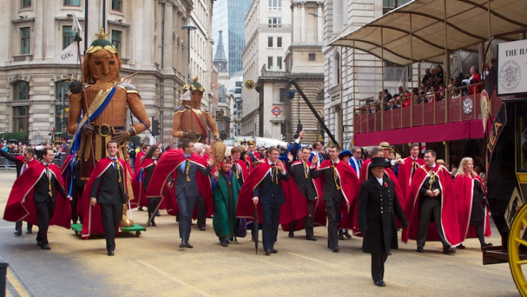
Gog and Magog were legendary giants before the Anglos and Saxons and Vikings invaded Britain. Each second Saturday in November they are featured in the Lord Mayor’s Show in London. Gog and Magog were said to be descendants of a race of giants who inhabited Albion (pre Britain name). Gog and Magog are also names used for nations in Ezekiel 38 and 39 as well as Revelation 20:7-8. Gog and Magog are prominent statues in Westminster Abbey in London. Wales, Scotland and Ireland also have many oral traditions and literature depicting giants in the distant past. There are two traditions as to who constructed Stonehenge thousands of years ago: both traditions give credit to giants.

South Africa
In 1912 a fossilized human footprint was discovered that is 4 feet in length.

France
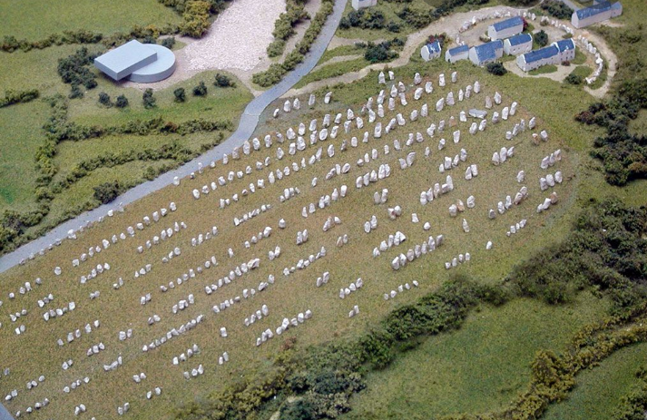
Who had the strength to bring these stones to this French plain. Tales of giants are part of European culture and history. Many recent archeological discoveries in Europe date human skeletons much older than the science and history books allow them to be.

Ecuador
An Austrian researcher named Klaus Dona pieced together a human skeleton 25 feet in height discovered in Ecuador at a place known as the cemetery of the giants.

Greece
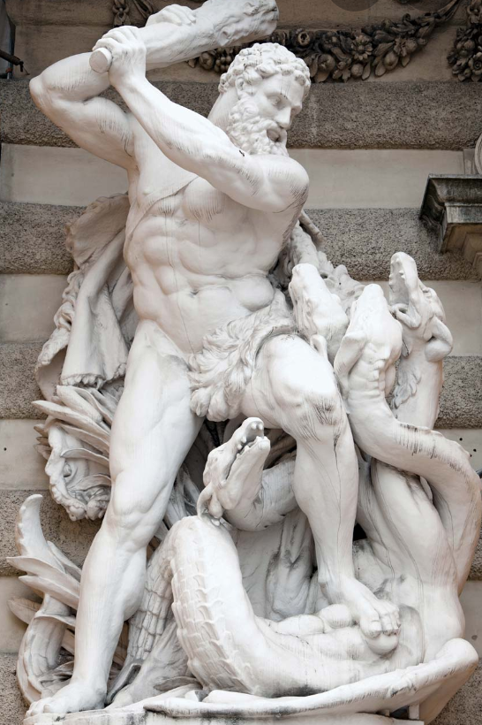
Is it possible that the “men of renown” described in Genesis 6 are the inspiration for the mythological heroes of the Greeks. Hercules is renown for his unmatched strength.

In Varna, Bulgaria which was part of ancient Greece (Odessos) January 2015 an enormous human skeleton was discovered.

Japan
An island of Japan had giant people inhabiting it until recent years. Video exists of such a large man walking among Japanese men and women.

Mexico
The Aztecs taught the land they inhabited was once ruled by giants.
I have stood on the summit of the Pyramid of the Sun at Teotihuacan and marveled not only at the architecture but at the cosmic alignments as well.
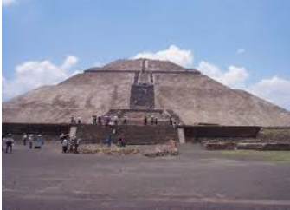
The Myan pyramids at Uxmal and Chichen Itza are also sites that awed me with their cosmic alignments. You may remember the Myan Calender stopped December 21, 2012.
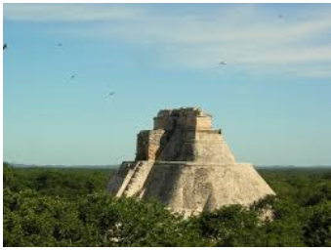

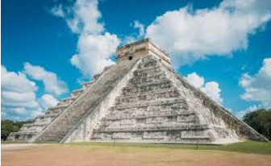

India
Supernatural heroes are said to have wared against each other long ago exhibiting godlike powers. Hinduism continues to worship these figures to this day. Many similarities between the ancient Hindu stories and those of the ancient Greeks and the Sumerians. The Hindu stories are filled with technologies that were not to have known to existed till very recent years.

New Zealand
The Mauri tell that a giant race inhabited the islands when their ancestors arrived. Many large human skeletons have been found by local people only to have the bones confiscated and the accounts dismissed by authorities.

Patagonia
Many early explorers documented very large people living in the southern tip of South America. English explorer James Byron claimed the giants of Patagonia were 9 feet tall. Byron’s claims were published by the London Chronicle. Writings from the expeditions of Sir Francis Drake, Francis Fletcher and Sir Thomas Cavendish documented giants living in Patagonia.
Ferdinand Magellan’s chronicler, Antonio Pigafetta, recorded that the crew of the ship standing next to theses giant men merely stood to the giants’ waists. It was reported that 2 of these massive men were taken on ship to return to Italy but both died in route.

Chapter 20
Megaliths

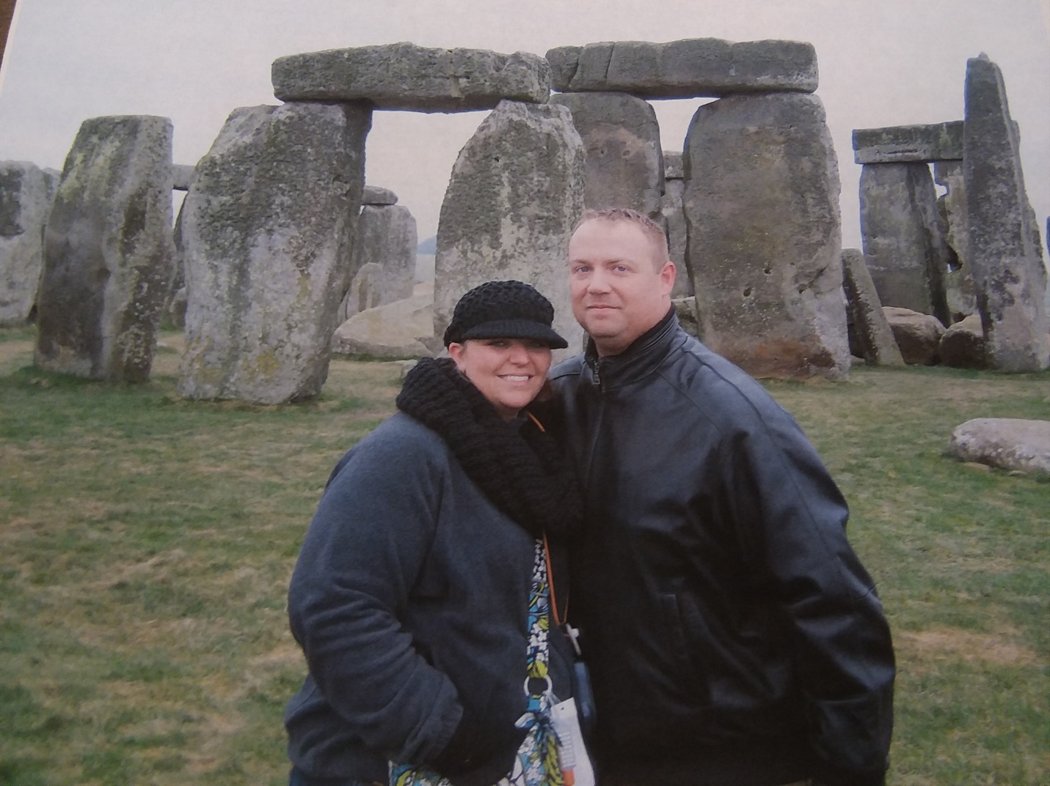

Stonehenge is the Anglo-Saxon name for this world renown megalith on Salisbury Plain. The original name means “the Giants’ Ring.” The stone was cut 450 miles away from where the ring has stood marking the summer solstice for thousands of years, yet no one can explain how the stones were moved to this location.
Smaller rings or henges are found all over the British Isles. Woodhenge is a group of 3 earthen rings in Britain that line up with the stars in Orion’s belt exactly the way the ancient pyramids of Egypt do. Incredibly, rings or wheels of stone are found all over the earth; South America, North America as well as the Middle East have megalithic stone ring sites.

Petra
Scholars do not know who carved this megalith or for what purpose it was constructed.

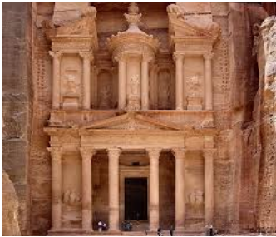
You may have doors this size at your home, church or office building, but I certainly do not!

Egypt
Many massive granite tombs have been discovered in underground tunnels in Egypt. Why would so many tombs need to be 20 feet long and 10 feet deep? Many massive granite stones were quarried in Egypt thousands of years before Egyptians had the capability to do so. How and who are questions that historians and anthropologist debate to this day.

Easter Island
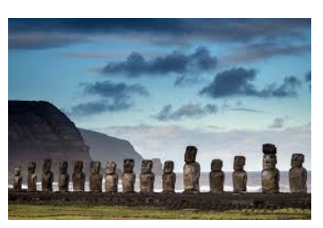
The Easter Island Megaliths have puzzled scholars for centuries. Oral traditions of the Polynesian islands say giants lived here.

Chapter 21
DNA Evidence

Neanderthals are an extinct species of humans that lived in Europe and Asia. This race was larger than modern man but did interbred with modern humans. Neanderthals have been a negative term in our culture for years describing primitive behavior in adults. However, the more Neanderthals are studied by academics the more complex the Neanderthals appear to have been.
In 2010 another human species different than us was identified by testing ancient remains recovered from the Siberian Denisova Cave. This species has been named Denisovans because of the first identified location. This species has been recovered and identified since 2010 thousands of miles from Siberia. These guys traveled and interbred with modern humans. It is believed that the Denisovans are the source of the gene in Tibetan people that enable them to live at high altitudes with low oxygen levels. Remains of this ancient race have been recovered in Africa, Asia, Southeast Asia, New Guinea and Australia. Examining modern DNA from living people reveals that Denisovans interbred with many modern humans worldwide. This race was much larger than the Neanderthals and the Neanderthals were larger than us.
Near the Altay Mountains in Siberia are the Gornaya Shoria Megaliths. Although, this is a site I have yet to visit, photographs of the megalithic site show the many 90 degree angles of cut stone forming a 130 foot structure. The stones forming the gigantic structure weigh in at 3 and 4 times the weight of the stones of Baalbek Lebanon that were once thought to be the largest in the world. No modern equipment is capable of moving the stones of Baalbek so how could ancient mankind move stones 3 and 4 time that weight to a height of 130 feet? Is it coincidence that this megalithic site is were the Denisovans once lived?

Chapter 22
Make Believe

“Fie, fih, foh, fum;
I smell the blood of an Englishman!” said the fabled Giant to Jack who had climbed the beanstalk. The story is 300 years old and children worldwide imagine the mythical tale. We are immersed by hoaxes and stories that have made us very cynical of things we do not see everyday.
More than one man has been arrested for staging an archeological dig; more than a few for faking the discovery of giant human bones. Pictures and false reports flood the internet with sensational claims that people laugh at. The Giant Problem is attempting to bring to the reader’s attention “giants who actually existed”, not merely the subject of make believe.
Football has the New York Giants. Baseball has the San Francisco Giants; formerly of New York. Young men at Wabash College are Little Giants. I grew up reading about Paul Bunyan, John Henry and Pecos Bill. The World Wrestling Federation was home to the late Andre the Giant who starred in the movie The Princess Bride that cashed in on his deformity known as giantism. “Inconceivable!”
“Ho, Ho, Ho; Green Giant!” For the last 116 years the Jolly Green Giant really has been bringing great canned and frozen vegetables to our homes.
Even tall tales like Jack and the Beanstalk have much older origins. The 18th century children’s version is the non-violent adaptation of Jack the Giant Slayer told centuries before. Jack was said to be a member of King Arthur’s round table. Could it be that ancient stories have factual origins?

Chapter 23
Logic

Today, many reject the Bible as factual or a reliable source for information. It is for readers such as these that I provided additional research such as accepted historical testimony and media sources. I realize that I may still have failed to convince you that giants once existed. But use logic: if you research the dozens of stories from each continent that tell of their ancestors surviving a massive flood in a large ship filled with animals, an old man, his 3 sons and their wives, it becomes very likely that these fables or oral histories start to have some validity. Likewise, the fact that the same cultures tell that giants once ruled the earth and were exterminated in this flood gives some traction to the reality of the ancient stories. From India to Greece the stories of the heroes of old fill our imaginations with what once was.
The stories of so many different cultures simply substantiate what the Bible says. Flavius Josephus explains the Greek stories of what actually occurred long ago.

According to the 1st Century Historian Josephus in Antiquities of the Jews 3 we read:
“…many angels of God accompanied with women and begat sons that proved unjust, and despisers of all that was good, on account of the confidence they had in their own strength; for the tradition is, that these men did what resembled the acts of those whom the Grecians call giants.”

He continues in book 5 Chapter 2:
“[They] removed their camp to Hebron; and when they had taken it, they slew all the inhabitants. There were till then a race of giants, who had bodies so large, and countenances so entirely different than other men, that they were surprising to the sight, and terrible to the hearing. The bones of these men are still shown to this very day, unlike to any credible relations of other men.”
My sincere hope having read The Giant Problem is that you now have a clear understanding of what Moses recorded in the Book of Beginnings:
The Nephilim were on the earth in those days – and also afterward – when the sons of God went to the daughters of men and had children by them. They were the heroes of old, men of renown. -Genesis 6:4

The Order of Events:

- Sons of God produced Nephilim and the earth was filled with violence. The Nephilim were on the earth in those days and also afterward.
2.) God destroyed the entire earth except who and what was on the ark.
3.) 4 kings’ armies defeat 5 kings’ armies thinning out the population of giants in Canaan. (Abram is promised by God that his descendants will one day call this land their own.)
4.) Abram’s militia defeats the 4 king army that had just thinned out the Canaan population. He has communion with Melchizedek and gives him a tenth of his possessions while refusing the gift of the king of Sodom.
5.) Moses and Joshua exterminated the clans of giants in Canaan while conquering the land God promised Abraham, Isaac and Jacob’s descendants.
6.) David kills the last remaining giants in Canaan and establishes his throne that will one day bring salvation to the entire world.
7.) Israel was exiled out of the land of Canaan because they worshiped Baal just as the Canaanites did.
8.) Christ came from the line of David in the fullness of time to bring salvation to ‘whosoever will receive it’.

Bibliography

Books

The Holy Bible, New International Version, Zondervan Publishing; 1984 Grand Rapids, Michigan (Pages 13-18, 21-27, 30-32, 36-39, 44, 47-52, 56-58, 61-65, 68-70, 72-74, 78, 94, 98, 100, 112, 126)

Matthew Henry’s Commentary on the Whole Bible, Fleming H. Revell Company Old Tappan, New Jersey

Halley’s Bible Handbook, Zondervan Publishing; 2000 Grand Rapids, Michigan

Strong’s Bible Dictionary

Vine’s Expository Concordance

1825 book entitled, Six Nations, Tuscarora tribe member David Cusick (Page 80)

Antiquities of the Jews, Flavius Josephus (Page 64, 91, 125, 126)

Epic of Gilgamesh, (Page 96, 101)

Jack and the Beanstalk, (Page 123)

Address

Abraham Lincoln, Niagara Falls 1848 (Page 84)

Newspapers

January 14, 1870 the Ohio Democrat published that a giant was unearthed in a mound near West Hickory with an enormous iron helmet and a nine feet long sword. The giant was said to be around 18 feet tall.
February 8, 1876 the New York Times published that 3 skeletons each 9 feet tall were found in a vault in a cave near Louisville, Kentucky.
July 14, 1880 the Marion Daily Star published that in Muskingum County, Ohio a male skeleton measuring 9 feet and a female skeleton measuring 8 feet were found in a burial mound. Clay tablets were also found with unidentified script.
February 9, 1890 the New York Times published that giant skeletons were being observed by the public in May’s Landing, New Jersey.
June 27, 1885 the Philadelphia Times published that 150 giant skeletons were found in a cave near the Pennsylvania/New York state line.
April 5, 1886 the New York Times published that the day before in Carterville, Georgia a flood receded exposing giant bones and skulls.
September 26, 1889 the Cincinnati Courier Gazette published that in a mound in southern Ohio a giant skeleton was excavated along with a large panther skeleton.
August 27, 1891 the New York Sun published that a skeleton measuring 8 and a half feet in length was discovered near Salt Lake City, Utah.
October 7, 1895 The World published that a skeleton was recovered. They also provided this famous photo.
December 20, 1897 the New York Times published that a nine feet tall skeleton was discovered in a burial mound near Maple Creek, Wisconsin.
January 17, 1899 the Middletown Signal published that a skeleton measuring 8 feet 1 and ½ inch was discovered near Miamisburg, Ohio.
February 11, 1902 the New York Times published that Archeologists were examining giant skeletons that had been unearthed in New Mexico.
May 4, 1908 the New York Times published that a cave in Mexico contained over 200 skeletons of men over 8 feet in height.
July 14, 1916 the New York Times published that scientists had unearthed giant skeletons in a burial mound that were 700 years old.
1931 Nevada Review-Miner
January 7, 1940 the San Antonio Express published that WPA workers had unearthed giant human skulls.
The London Chronicle, (Page 116)

Movies

Indiana Jones: Raiders of the Lost Ark, Lucasfilm Ltd./ Paramount Picture, 1981

The Princess Bride, 20th Century Fox, 1987

Maps

Drawn by Jim McPhereson, 2020 (Pages 34, 41, 54)

INDEX

Map 1 page 34

Map 2 page 41

Map 3 page 54

Pictures page 44, 86, 88, 92, 95, 98, 100, 102, 105, 107, 110, 111, 112, 113, 114, 115, 116, 119, 120, 121

Old Testament Books
Genesis pages 50, 56-58, 61, 63, 64, 98, 100, 126

Numbers pages 30, 31

Deuteronomy pages 32, 36, 37, 39, 62, 69, 70,

Joshua pages 38, 39, 47-49, 51, 52, 63,

I Samuel pages 13-18, 21-25, 26-27

II Samuel pages 27, 63

I Chronicles page 18

Psalms pages 44, 62

Proverbs page 49

Job page 62

Isaiah page 19

Jeremiah pages 68, 69

Ezekiel page 112

Daniel page 62

Amos pages 31, 94

New Testament Books
Matthew pages 62, 78

John page 62

Galatians page 72

Ephesians page 72

I Timothy page 74

II Timothy page 63

Titus page 74

Hebrews page 73

I Peter page 64

2 Peter pages 63, 65

Jude page 63

Revelation page 112

Names
Abraham page 56, 57, 58, 59

Agag page 25

Amalekites page 25, 26

Anak page 31

Caleb page 30, 31, 32, 33, 34

David page 13, 14, 15, 16, 17, 18, 19, 21, 22, 23, 24, 25, 26, 27, 28

Denisovans page 123, 124

Emites page 30, 31, 32, 33, 34

Flavius Josephus page 91, 92, 125, 126

Goliath page 13, 14, 15, 16, 17, 18, 19

Hebrew page 16, 17, 18, 19

Jesse page 21, 22, 23, 24, 25, 26, 27, 28, 29, 30

Jesus page 24, 72, 73, 74, 75, 126

Joshua page 30, 31, 32, 33, 34, 47, 48, 49, 50, 51, 52, 53, 54

Maximinus Thrax page 105

Moses page 30, 31, 32, 33, 37, 38, 39, 40, 41, 42

Moabites page 28

Native Americans page 80, 81

Neanderthals page 123

Nephilim page 32, 61, 62, 63, 64, 65, 66, 125, 126

Nimrod page 94, 95, 95, 98, 99, 100, 101, 102, 103
Orion
Gilgamesh
Baal

Noah page 61, 62, 63, 64, 65, 66

Og page 37, 38, 39

Philistines page 13, 14, 15, 16, 17,18, 19, 21, 22, 23

Rapha page 30, 31, 32, 33, 34, 43, 44, 45

Rephaites page 30, 31, 32, 33, 34, 43, 44, 45

Samuel page 21, 22, 23, 24, 25

Saul page 13, 14, 15, 16, 17, 18, 19, 21, 22, 23, 24, 25, 26, 27, 28

Sons of God page 61, 62, 64, 65, 74, 91, 125, 126

Zamzummites page 32

Locations
Baalbek page 97, 98, 99, 102

Babylon page 68, 69, 70, 102

Bashan page 35

Bolivia page 113

Britain page 115

British Museum page 92, 98

Bulgaria page 117

Canaan page 17, 31, 74, 75, 126

China page 114

Easter Island page 124

Ecuador page 116

Egypt page 21, 103

France page 116

Gilgal page 22, 35

Gornaya Shoria page 123

Greece page 94, 117

Hebron page 34, 41, 94

India page 119

Israel page 13, 14, 15, 16, 17, 24

Japan page 118

Jericho page 35

Judah page 13, 15, 24

Lebanon page 102

Mexico page 118, 119

New Zealand page 119

Patagonia page 119, 120

Persia page 73

Peru page 113, 114

Petra page 123

Rome page 94

Russia page 115

Stonehenge page 45, 98, 122, 123

South Africa page 115

NOTES

NOTES

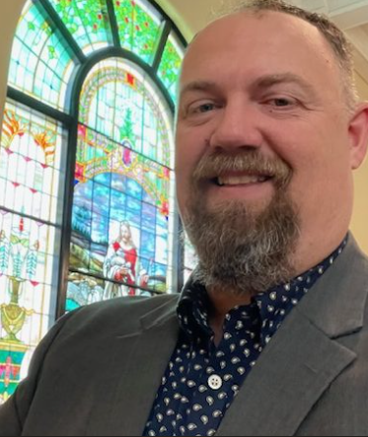
About the Author
Byron Holtsclaw has been the minister of First Christian Church in Washington, IN for 18 years. He is married to his wife Lora of 24 years. They are the parents of Seth, Liberty and Charles. When Byron and Lora are not ministering, they are encouraging their adult children. Byron has published Bible Study lessons, articles, books and has hosted radio programs. His passion is teaching people God’s word. Byron’s prayer is that his research would help people understand the fullness of God’s grace and mercy.

About the Book
During Byron’s ministry he has trained church leaders in 5 states and 15 countries. While teaching disciples of Christ, Byron is often asked difficult apologetic questions. Many of these questions are originally asked by non believers of Christ who point out theological reasons why they cannot accept Jesus Christ as God’s Son. The Giant Problem is the answer to the question, “Why did God order the extermination of the people living in the Land of Caanan?” God’s command to the people of Israel was just part of a much larger issue. Byron Holtsclaw takes the reader back to the beginning and works through the theological truth of Scripture to reveal the precision and effectiveness of God’s divine and just plan for the salvation of us all. The Giant Problem is an exegesis of Old and New Testament containing Scriptures from 27 books in the Bible as well as the writings of historians, witness accounts, and the research and discovery of archeologists and anthropologists. The Giant Problem is intended to be read in conjunction with a Holy Bible and reference materials.

For much more study on many Biblical subjects please visit:

www.chistiandiscipleshipministries.com

